
Nathan Schnaper Summer Intern Program in Translational Cancer
Research (NSIP) (http://umm.edu/programs/cancer/research/nsip)


Program Description: The goal of the NSIP is to provide integrated research, educational and clinical experiences that emphasize the translation of laboratory discoveries into clinical applications and inspire the next generation of cancer researchers and physician-scientists. Towards this aim, the NSIP has trained over 200 interns in the past 30 years. Over 85% of NSIP alumni matriculate to medical, graduate and other professional degree programs and many have made seminal contributions to the field. The internship is named after the late Dr. Nathan Schnaper, an ardent advocate for cancer research and training of aspiring physician-scientists. Dr. Bret Hassel has directed the NSIP since 2001 and is Principal Investigator of a National Cancer Institute Grant to support the Program.
Dr. Nathan Schnaper
1918-2010
- NSIP training occurs at the University of Maryland Baltimore (UMB) that is home to schools of Medicine, Pharmacy, Dentistry, Public Health, Nursing, Social Work, and Law. Also part of the UMB campus is the University of Maryland Medical Center that is comprised of University Hospital, the R. Adams Cowley Shock Trauma Center and the NCI-designated UM Greenebaum Cancer Center (UMGCC) that hosts the NSIP. This major academic medical center brings together state-of-the-art research and clinical facilities with faculty expertise in medical education, biomedical research, patient care and community service. In this stimulating environment, NSIP interns gain an important perspective of the bi-directional flow of information between the laboratory and clinic in the context of our battle against cancer.
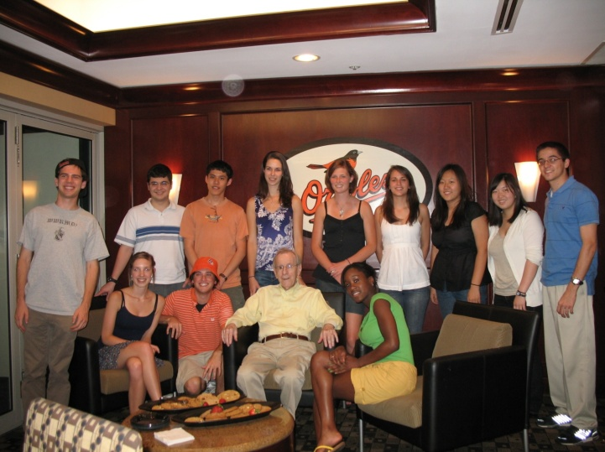
- Undergraduate students accepted into the ten-week NSIP are matched with UMGCC faculty mentors to conduct projects in cutting edge areas of basic, translational and clinical cancer research including targeted drug discovery, signal transduction, apoptosis and metastasis. The program begins with a Laboratory Practice and Techniques course at Loyola University Maryland to provide hands-on training with methods interns will use in their research. In addition to laboratory research, interns learn about current topics in cancer research and career paths in biomedical sciences through ‘Meet the Mentors’ discussions and seminars in conjunction with the Office for Student Research. A ‘Translational Cancer Research: bench-to-bedside-and-back’ lecture series and small group analysis of ongoing clinical trials with UMGCC Fellows provides interns with specific examples of a translational pipeline in action. Interns gain direct exposure to clinical oncology through shadowing UMGCC clinicians. Social activities provide an opportunity for informal interactions with mentors and learn more about the UMGCC research community. At the conclusion of the internship, the interns deliver oral and poster research presentations in campus-wide research forums.
‘09 interns at Orioles game with Dr. Schnaper

Eligibility and Requirements:
- Undergraduate students with a genuine interest in cancer research, cumulative GPA >3.0, and strong letters of recommendation as reflected in their application packages, are eligible.
- Applicants must be US citizens or permanent residents.
- Underrepresented minorities are encouraged to apply.
- Twenty internships are awarded each summer; applications for these slots are reviewed by committee and evaluated on a competitive basis
- The NSIP is a full time ten-week commitment beginning in the last week of May that is not compatible with concurrent outside employment or classes; see website for this summer’s program dates.

- Subsistence Allowance and Housing:
- Interns receive a subsistence allowance of $4,000 for the 10-week internship.
- Apartment-style dormitory housing is available at Loyola University Maryland. (http://www.loyola.edu/admission/undergraduate/life-at-loyola/housing-dining)
- A travel allowance of up to $500 is provided for travel to and from Baltimore.

How to Apply:
The following application materials will be accepted beginning 12/1/15 and must be received by March 1, 2016:
1. Online application form including a brief essay describing how the internship will foster your academic/career interests.
2. Two letters of recommendation using the online forms submitted to NSIP@som.umaryland.edu.
3. Transcript of your grades (must include Fall semester grades and be submitted electronically if possible)

For further information contact the NSIP Director
Dr. Bret Hassel (bhassel@som.umaryland.edu)
University of Maryland Marlene and Stewart Greenebaum Cancer Center
685 West Baltimore Street, HSFI room 380, Baltimore, MD 21201

Applicants will be notified of the Committee’s decision by April 1, 2016; program begins the last week of May

