
Section I:

(Leader/Chair/Official Contact Person)
- Name: Heather Hrycyshyn UMBC Email: heathr1@umbc.edu
Day Phone: (201)-213-1026 Evening Phone:
Student ID Number: ID36099

- Name: Paul Young-Jin Lee UMBC Email paullee1@umbc.edu
Day Phone: 240-418-6773 Evening Phone:
Student ID Number: CT38019

- Name: Valerie Shore UMBC Email: valsho1@umbc.edu
Day Phone: 201-213-1026 Evening Phone: 301-916-0936
Student ID Number: AO26613

- Name: Theresa Wachter UMBC Email: twach1@umbc.edu
Day Phone: 443-610-0822 Evening Phone: 443-610-0822
Student ID Number: UP90569

- Name: Max Tucker UMBC Email: mtuck1@umbc.edu
Day Phone: 443-250-4295 Evening Phone: 410 526 0036
Student ID Number: LY68899

- Name: Robert F. Bonfante UMBC Email: bro3@umbc.edu
Day Phone: (410) 459-7203 Evening Phone: (410) 459-7203
Student ID Number: PZ06126

- Name: Tanvi Gadhia UMBC Email: tanvig1@umbc.edu
Day Phone: 410-419-5664 Evening Phone: 410-529-3017
Student ID Number: DT 90207
Section II:
Part 1: Overview
Currently the food served at UMBC is predominately grown by industrial agribusinesses growing large scale crops of few varieties of Genetically Modified Organisms with intense use of pesticides, herbicides, and fertilizers, damaging soil and water quality in addition to public and consumer health. In order to preserve biodiversity, reconnect the UMBC community with food and one another, and reduce global transportation impact on climate change, we propose a garden.
We propose a community garden to be run exclusively by students and volunteers, helping to provide cohesion amongst different groups of students while improving the health and quality of the campus. The garden will provide many opportunities for student organizations, professors, researchers, and other programs to learn and share by cultivating their own plot of land. Serving as a gathering place through the inclusion of picnic tables, open volunteer workdays, workshops and training events, the garden will also include educational displays, and academic research project opportunities in various fields including but not limited to nutrition, science, art/design installations, engineering/building, monitoring and research. It will be a place for socializing along with hands on opportunities for students to employ the skills and knowledge we acquire here.

We will grow rare heirloom species organically in order to provide meals to dining services and individual plots will also be available for students, staff, researchers, professors, and groups. Following a global and regional trend towards sustainability, UMBC will take the lead in food efficiency and sustainable development. The campus land was once agricultural, a place of high productivity thanks to rain, soil, and a temperate climate. Implementing a garden will also preserve our history while creating a legacy.

Part 2: Benefit to UMBC
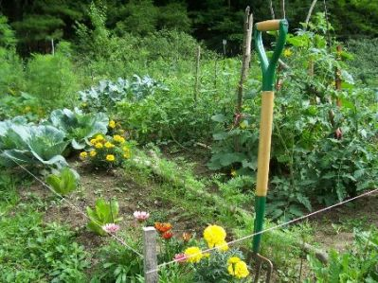
A Community Garden has the power to address many campus issues and needs, such as sustainability, community, aesthetics, and beautification. Our garden will promote health and well-being, while providing a place for relaxation, exercise, learning, and growing. Anyone can come and socialize with a fun, natural way to be physically active and use leisure time productively.

SIT Institute Garden
The garden will also aide in fostering a new equitable forum for interactions between staff, students, researchers, professors, administrators and anyone else in and around the UMBC community. The garden’s existence will establish a connection for UMBC between nature and food; this opportunity will give UMBC a chance to actively participate in improving their environment, nutrition, and overall health. Having a garden directly on campus, which will provide food for Chartwells, will also help to reduce the cost of transportation by providing direct, easily accessible food for the company to use. A community garden will also help to reduce UMBC’s overall carbon footprint, a goal our president himself has promised to address through the American College and University Presidents Climate Commitment. As an institute for higher education we must set the example and lead toward positive change.
In addition to enriching student life, the garden will also advance the academic opportunities for students. Increased efficiency and local food production will help change the way people think about how we obtain and protect our natural resources that are vital to our survival. Realizing that we can acquire food safely and efficiently in our own community will provoke a greater appreciation and investment to the physical space that our school occupies.

SIT Institute Garden

Part 3: Implementation Plan
There will be a new student organization created specifically to oversee the community garden. This organization will be in charge of managing funding, maintenance and work schedules while planning events and training those who wish to get involved. The Community Garden Committee will oversee the divvying up the different plots and responsibilities including but not limited to the maintenance orf herbs, vegetables, and composting between the different groups involved with the garden. There will be a fixed rotational schedule for these responsibilities for the members of participating groups, which will involve a scheduled representative to work on the plot at least once a week. A work plan and schedule will be submitted to the Committee each month. If the assigned member is unable to work that week, then it is up to that member to find a replacement. It is also important that training for new members who want to help in or with the garden is made available, as well as systematic and structured openings for people who want to be involved for short periods of time. In the future, The Shriver Center will work with us to create a program where long-term committed students who help create educational outreach events, fundraise, and organize volunteers can earn transcript notation for all of their hard-earned community service.
The garden will be divided into two main plots, one for the sole purpose of growing edibles to serve to the UMBC community through our partnership with Chartwells, the current dining services provider, and the other for the personal use of several students, academic, and other groups. The Baltimore area is well suited to growing many of the staple vegetables used in both the prepared foods that the dining hall offers and the individual items in the salad bar in addition to an herb garden requested by dining hall chefs. In order to highlight the implementation of the garden into the dining hall, there will be featured dishes or stations that use labeled garden fresh organic produce, or certain days of the week where the majority of the meals incorporate the vegetables that we grow from the garden. The dining hall will advertise these special means through the use of spotlights, postings on the UMBC dining website, and signs on True Grits. Another initiative is to have “Fresh Fusions” station in the Commons serve garden produce once a week. In the future, based on the success and demand of the produce served, we hope to expand the garden to size where almost all vegetables on campus will come from our organic garden by involving a broader population of the UMBC community. If when the 10 year contract with Chartwells expires UMBC acquires a new contractor we also may establish a co-op built in order to distribute the vegetables, herbs, and fruits grown, to make enough profit to sustain the materials and maintenance used on the garden.
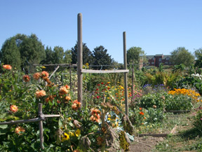
The remainder of the garden plots shall be made available for rental to student organizations, residential halls, academic departments, professors, researchers, student groups as well as staff on campus. A group of four of more may sign up to take on a plot, or a group smaller can have one fourth of the 8x8 foot plot (64 sq ft for groups, 16 sq ft for individuals or teams). Interest in plots has been expressed by several professors seeking to incorporate plots into their courses (Dr. Laura Lewis and Dr. Matthew Baker of Geography and Environmental Systems). Additional groups who have already approached us with interest in taking on plots have been the Shriver Center Peaceworker Program, Residential Student Association, UMBC Vegetarians, SGA departments of Health and Wellness and Environmental Affairs, Students for Environmental Awareness, and the English Language Center. Each month plots will be evaluated and those that are not maintained will receive a warning, If the plot remains disorderly in the following month the area will be revoked. Groups sign up to plant and care for their plot each season, but can also sign up for longer term commitments if they show they are capable and dedicated owners. A log book will be located at the shed and each time a volunteer spends time on a plot this will be recorded. Every week, the student organization will host regularly scheduled ‘work days’ where groups of volunteers spend time looking after the garden together, with trained and experienced gardeners directing the work. Any group signing up for a plot must have at least two representatives go through training from one of our ‘Master Gardeners’ (we will hold a workshop with the University of Maryland’s Agricultural Extension’ Master Gardeners program annually to maintain skilled members).
Reed College Garden
In addition to the commitment Chartwells has made to volunteer over the summer in order to maintain the plot we shall host large and well advertised harvesting events in June, July and August. We will also actively outreach summer programs and summer campus residents to ensure that there are at least 4 committee members and 16 volunteers committed for those summer months. The garden will be well lit to discourage vandalism using outdoor lights that store energy collected by solar panels.
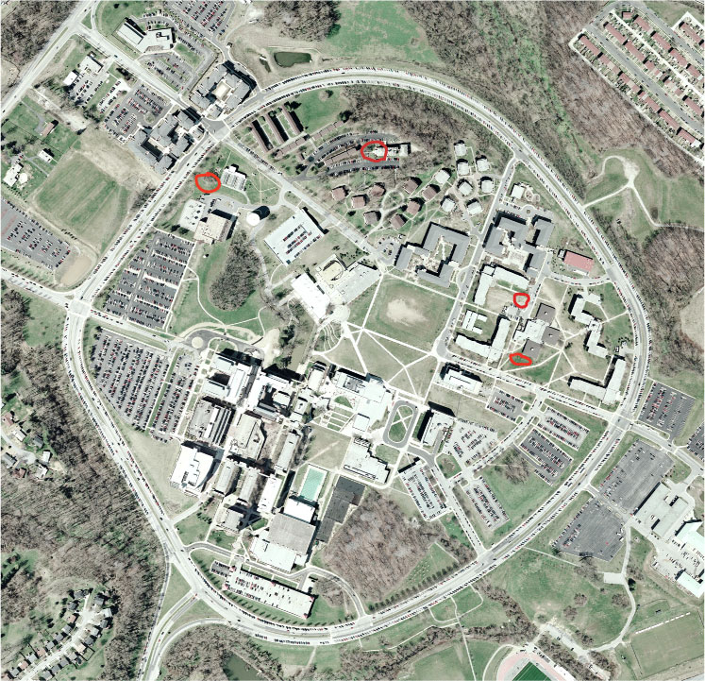
Each month during the fall and spring semesters, the student organization will host volunteer events where anyone can come to the garden and contribute to projects such as weeding, construction, mulching, planting, painting, harvesting, and so on along with experienced gardeners to provide guidance and advice. In addition, the student organization will host trainings and workshops at least once a month in order to pass along knowledge and bring the community together. Things such as soil PH testing for chemistry students, plant overgrowth and domination for biology students, and natural pesticide experimentation for environmental studies students are just some of the innumerable possibilities on the table. We also plan to have a sections solely devoted to indigenous edible species and native medicinal plants in order to educate students about what grows in their very own backyards. This section, in addition to academic and human consumption concerns, will educate the general student body about the rarely known uses of plants that they only interact with when stepping on them in their rush to get to class.
We currently have consulted and been granted approval from Donna Anderson of Facilities Management, who will also allow us to borrow equipment, should our plan get approved. After looking over a map with Mrs. Anderson and the Master Plan, we were recommended several locations that might be considered appropriate. From those we consider, the area behind Chesapeake Hall and the Dining Hall seemed most preferable. This site is ideal because of the amount of sunlight it receives and its location close to a large part of the campus population both academic and residential. The size of this area has been surveyed through the use of Google Earth, and the flat area behind Chesapeake Hall and the Dining Hall is roughly 90’ feet by 104’ feet. The fenced in plot will be 88 by 88 with 8x8 plots and 4ft wide walkways between plots. (Please see Attachment A for Garden Layout and Location).
Four Possible Garden Locations are Outlined in Red
The section of the garden holding the plants will be enclosed with fencing. In front of the garden will be a gathering space with fruit trees. Included in this section shall be picnic tables so that events may be held and people may relax while planting or harvesting. The garden will also include several other elements adding to the beauty and aesthetic appeal of the garden working with artists within the UMBC community to contribute works, paint murals, and create displays illustrating clearly what the garden is labeling the contents and plot owners clearly. We will also encourage wildlife through butterfly bushes, bird baths, and bird feeders.
We will purchase three rain barrels from the Herring Run Watershed Association (to be installed at down spouts on Dining Hall please see Attachment A). Pre-built rain barrels would cost us $75 dollars each, totaling to $225. The Watershed runs a create-your-own rain barrel program which would be a beneficial activity to bring to campus as an educational and community building program, lowing the cost to $65 each, totaling $195. We also hope to build a butterfly garden/habitat as well as design and create bird feeders and birdbaths, all to promote beautification towards the campus and encourage wildlife for observation. In the garden we will employ permaculture, biodynamic, polyculture, and organic progressive methods, including self-sufficient techniques such as rain barrels and composting.
The fence will consist of vertical wooden planks 4 feet high topped with a two-foot trellis totaling 6 feet in height. The fencing will have two gated entrances with an arch, so that people will be able to enter from both sides of the area, with the outer perimeter of the fence lined with berry bushes. The picnic area in front of the gate to the garden will have several wooden picnic tables and will be shaded by several fruit and nut trees, for a gathering space and events. (wasn’t this already mentioned?) Also, several benches will be placed inside the garden area. These picnic tables and benches will be wooden, and may be constructed out of recyclable or sustainable materials. Eric Harting, President of UMCB chapter of Engineers without Borders has drawn up designs and volunteered to oversee and recruit volunteers to construct the gazebo, picnic table, and benches.
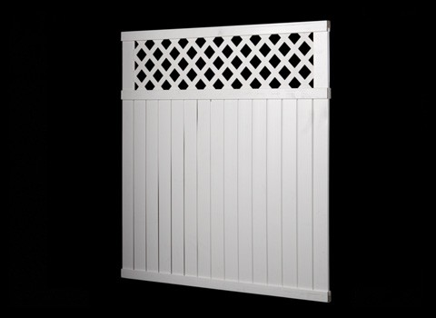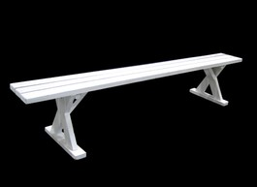
Left: 6x6ft Fencing Section; Center: Archway entrance; Right: Picnic Table
The garden will be an organic, non-toxic environment, using only organic and natural methods of fertilizing, pest containment, and no genetically modified seeds, though beyond those parameters groups are welcome to plant whatever and however they wish. This means everything from the soil to the seeds will be attained from natural sources or bought from certified dealers. We will be supplied with soil from a program in Baltimore County that gives away soil and mulch made from composted yard materials that would provide much needed nutrients to our plants while being cost efficient, as they give it away for free. This frees up much needed room in the budget for the seeds that we order as more money means greater variety in the vegetables we grow.
The first priority for implementation should be the vegetable garden fencing and beds. This needs to be done before planting begins, so that the plants can survive. Also, the raised beds for planting need to be completed before the plants can be planted. The next level of implementation should be the benches, pathways, picnic tables, shed, and picnic area fencing. These should be done as soon as possible as well, but the fencing and beds remain the first priority. Finally, the gazebo, fruit trees, berry bushes, pond, and other aesthetic or comfort additions should be the last priority.
The proposed UMBC community garden will have several exciting plans for its future in terms of aesthetic development and community outreach. Once the garden has exhibited some substantial growth and gained increasing support from students, a fish pond may be built next to the garden. The fish pond will provide enjoyment to visitors of the community garden with its beauty, life, and natural addition to the tranquil atmosphere of the site. In addition, the pond could serve as a water source and an irrigation system for the garden could possibly be constructed.
Another projected future development for the UMBC community garden is some outreach in the Catonsville community through Shriver Center interns. Some potential organizations to connect with include: the Catonsville Recreation and Parks Council, the many schools in the area (such as Catonsville Elementary, Hillcrest Elementary, Catonsville Middle School, and Catonsville High School), and the scouting groups in the area (Girl Scouts of Central Maryland Community 51, Catonsville Junior Girl Scout Troop 1103, Boy Scouts of America Troop 462, and Boy Scouts of America Troop 456). It would be ideal to contact the Catonsville Recreation and Parks Council to see if they would like to become involved with UMBC’s community garden or even just provide some helpful advice. Also, the schools might be interested in offering their students the opportunity to volunteer at the community garden at UMBC. Elementary and middle schools could go on field trips to UMBC to learn more about gardening and the environment, while high school students could volunteer at the garden to gain required service hours. These types of volunteer experiences could also be feasible for the various scouting troops around Catonsville. The girl scouts and boy scouts might be able to earn patches for working in the garden. The Baltimore County Master Gardeners Program “Eat it, Grow it” with the Maryland Agricultural Extension has agreed to offer support and trainings to our garden.
Our Facebook Group, UMBC Community Garden has 226 members as of Tuesday, December 22, 2009 (<http://www.facebook.com/group.php?gid=172262512461&ref=ts>). We have 74 supporters who have signed up on our website http://umbcgarden.blogspot.com (see Attachment B).

Part 4: Timeline
March 2010: Prove It! Winner announced.
- Form Student Organization
- Interview and Hire Interns by April 15
- Meet with students and others interested in assisting in design and purchasing
- Order & obtain all needed materials by April 15
April 2010: Form partnerships, delegate plots
- Advertise for Volunteer Day& Plots
- Host Volunteer Day for construction of fencing/ area prep (raised beds)
- Host Volunteer Day for construction of compost heap
- Host Volunteer Day for Planting of communal garden for Chartwells
- Coordinate Volunteer activities with Earth Day, Students for Environmental Awareness’s Ecofest and UMBCserves Volunteer Week
May 2010:
- Dedication Event

Beginning in March 2010, the Prove it! Winner will be announced. From here, an intern will be hired to help with the production and creation of the garden. We will then host a meeting with all students and professors who are interested in assisting in designing the garden. All needed materials for the construction and implementation of the garden will be ordered and obtained. We will then advertise for a volunteer day and for open plots that will be available for all interested student organizations, researchers, and anyone else who wishes to have a plot. We will form partnerships from these interested parties, and delegate out specific plots. After finalization of partnerships and plots, we will host a series of volunteer days, each pertaining to different areas of construction and development for the garden. The first volunteer day will focus on the construction of fencing and area preparation for the garden. The second volunteer day will be for the construction of the compost heap, while the third volunteer day will be exclusively for the planting of the communal garden for Chartwells.
Part 5: Budget
Item | Quantity | Price | Total
Entrance: Arch/Gate | 2 | 400 | 800.00
Fencing (ft) | 352 | 15 | 5,280.00
Rain Barrels & Hosing | 3 | 300 | 900.00
Soil |  |  | 0.00
Gazebo | 1 | 2,000 | 2,000.00
Shovels & Equipment | 300 | 8 | 2,400.00
Storage shed |  | 8x8ft | 1,210.00
Wood for
Picnic Tables | 200 | 6 | 1,200.00
Benches | 100 | 12 | 1,200.00
Raised Beds | 60 | 60 | 3,600.00
Record Keeping Supplies |  | 100.00 | 100.00
Event Budget |  | 3,000.00 | 3,000.00
Signs & Displays |  | 300.00 | 300.00
Advertising Costs |  | 1,000.00 | 1,000.00
Seeds & Plants |  | 4,000.00 | 4,000.00
Intern Stipends | 1,000 | 3 | 3,000.00
Total |  |  | 29,990.00

Attachments:
- UMBC Community Garden Proposal: Location & Layout:
  - Location
  - Garden Layout
- List of Supporters
- Partnerships
- Goucher: Example of a Successful Campus Community Garden
- Rutgers: Example of a Successful Campus Community Garden
- Letters of Support:
  - Landscape and Stewardship Committee
  - Chartwells
  - Shriver Center
  - Mary Norell, President, Students for Environmental Awareness
  - UMBC Vegetarians
  - Dr. Eugene Parker, Chair, Geography and Environmental Systems(GES) Department; Founder, Conservation and Environmental Research Area; Landscape and Stewardship Committee; Master Plan Committee.
  - Dr. Laura Lewis, GES Professor, Baltimore School Food Project
  - Dr. Warren Belasco, AMST Professor, Baltimore School Food Project
  - Dr. Matthew Baker, GES Professor

