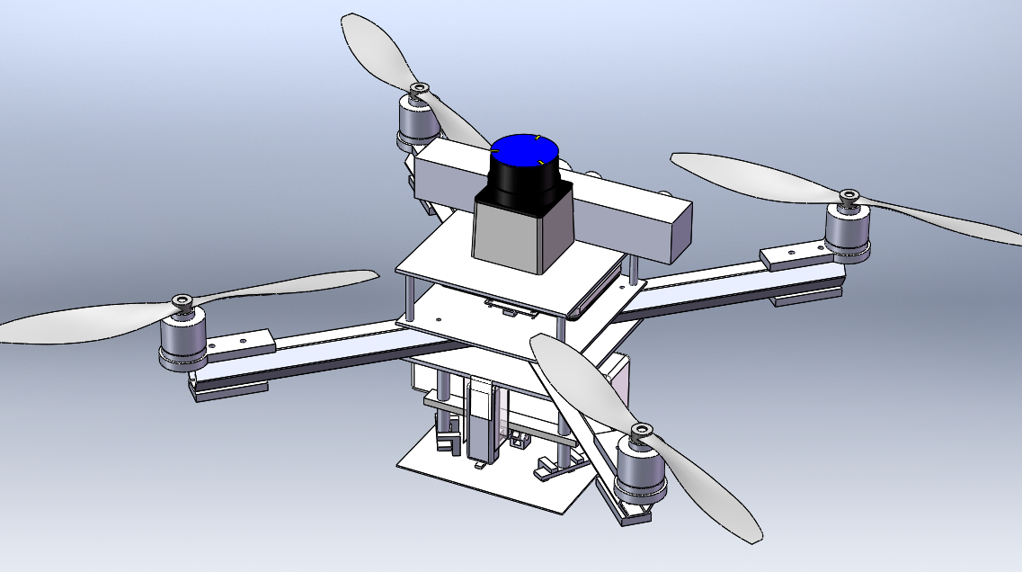

Note: UAV Meeting is held from 12:00-1:00 PM in ENG112. Schedule is subject to change.

UAV Meeting

UAV Meeting

UAV Meeting

Mar. 11

Mar. 18

IEEE Workshop

Mar. 9

Mar. 4

Ladies and Gentlemen,

On Monday, I finally got some idea as to how and when we will get funding for our club. The SGA has told me that a finance board requires that we come up with a wish list of equipment/parts that we would like to have complete with pricing, part numbers and sources of purchase. I currently have one of the teams researching some drone kits and another experienced UAVer putting together a list of club launching essentials. This preliminary order will hopefully get us started. In the future, I hope we will have the funds to be a little more liberal with how we order/upgrade our drones and accessories.

Next meeting we will need the teams to start discussing when they plan to meet on their own. They will be able to collaborate and work together but that is entirely up to each team. We will still have the club meeting to work on the drones as well. The teams will be finalized on Wednesday.

I would like to thank Shain and Steph and all the volunteers for setup, recruitment and presence at the UAV booth during the Demo Day and Tech Fest. Even if we got 15 names, it was a success. However, I would have liked an actual drone showcased.

Ben Cordell

UAV Club President

New Members,   
Please see Benjamin Cordell about joining one of the three teams and let him know if your commute is an hour or more north of UMBC as there is a team specifically designated for long distance commuters.

### Upcoming Events

# Club Update Address

Volume 1 Issue 3 March 3, 2015

Biweekly Newsletter

UAV Club

Spring 2015

[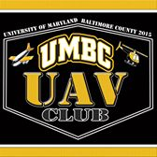](https://www.facebook.com/TheUAVClubofUMBC/photos/pb.1540691592868587.-2207520000.1423263509./1540695016201578/?type=1)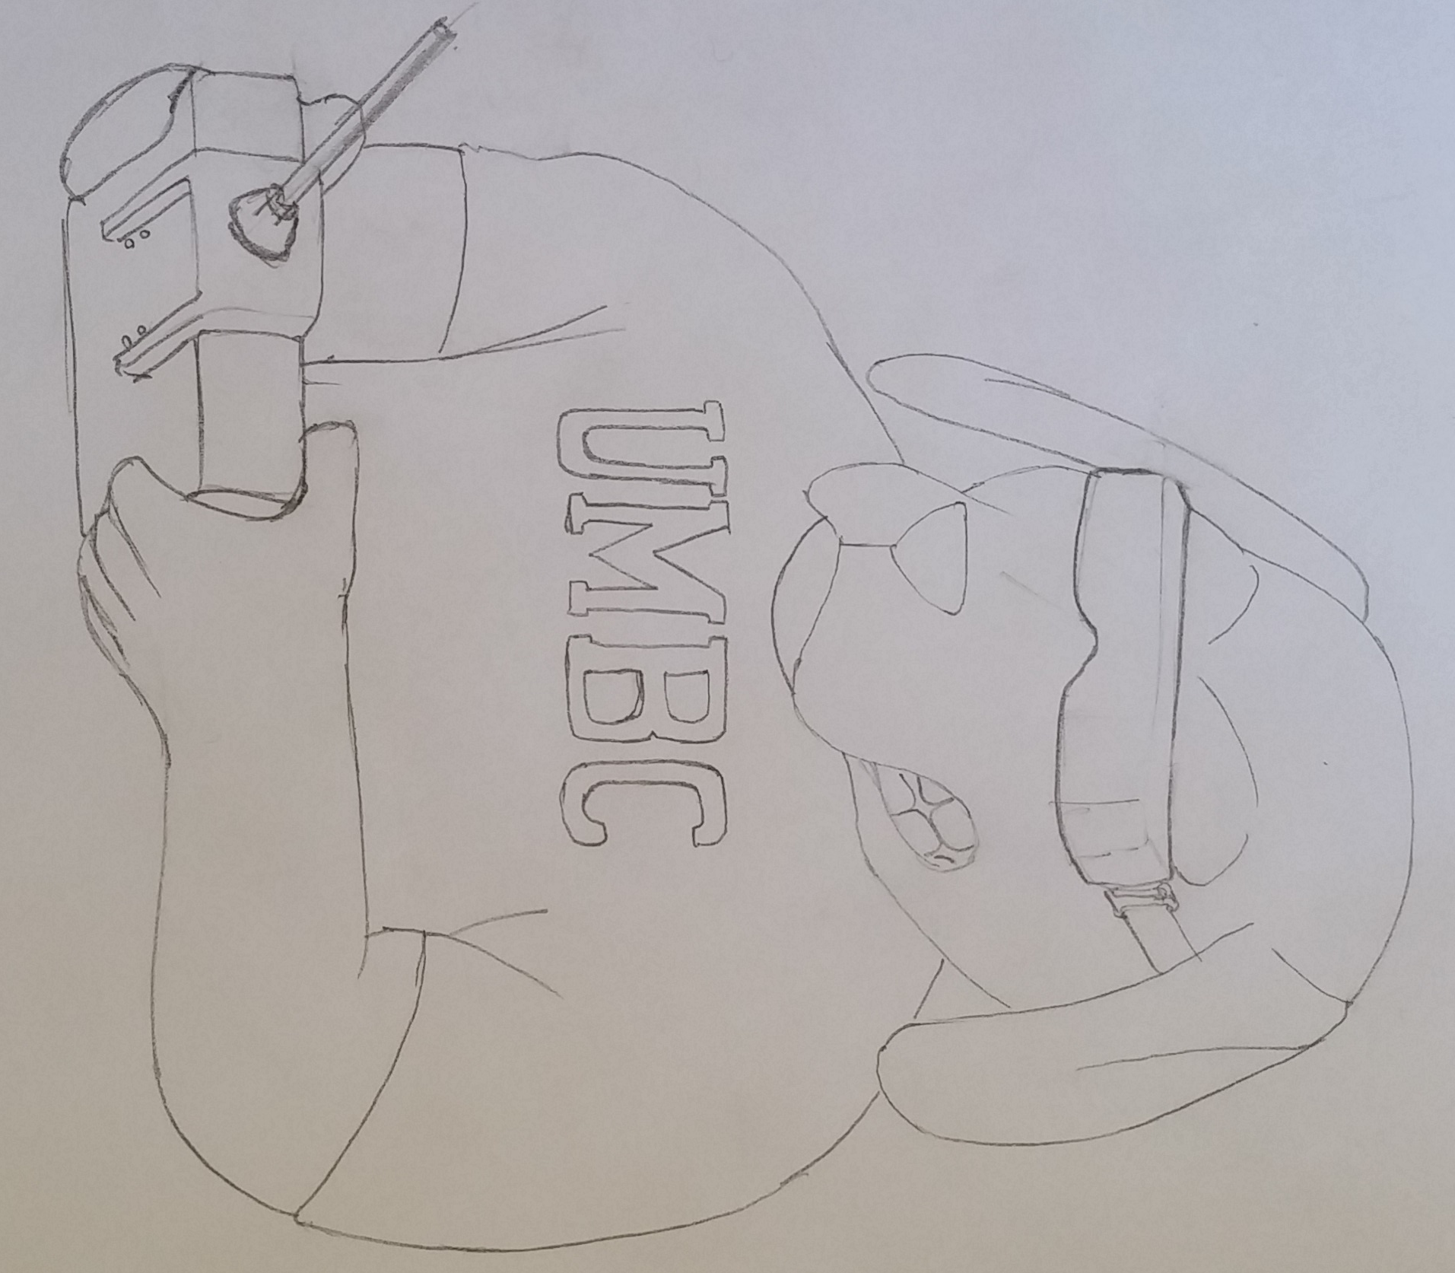

Please join the UMBC UAV group at [www.facebook.com/TheUAVClubofUMBC](http://www.facebook.com/TheUAVClubofUMBC)!

Once you have attended a UAV meeting, contact Andy Lee (alee20@umbc.edu) so that he may add you to the UMBC group page.

[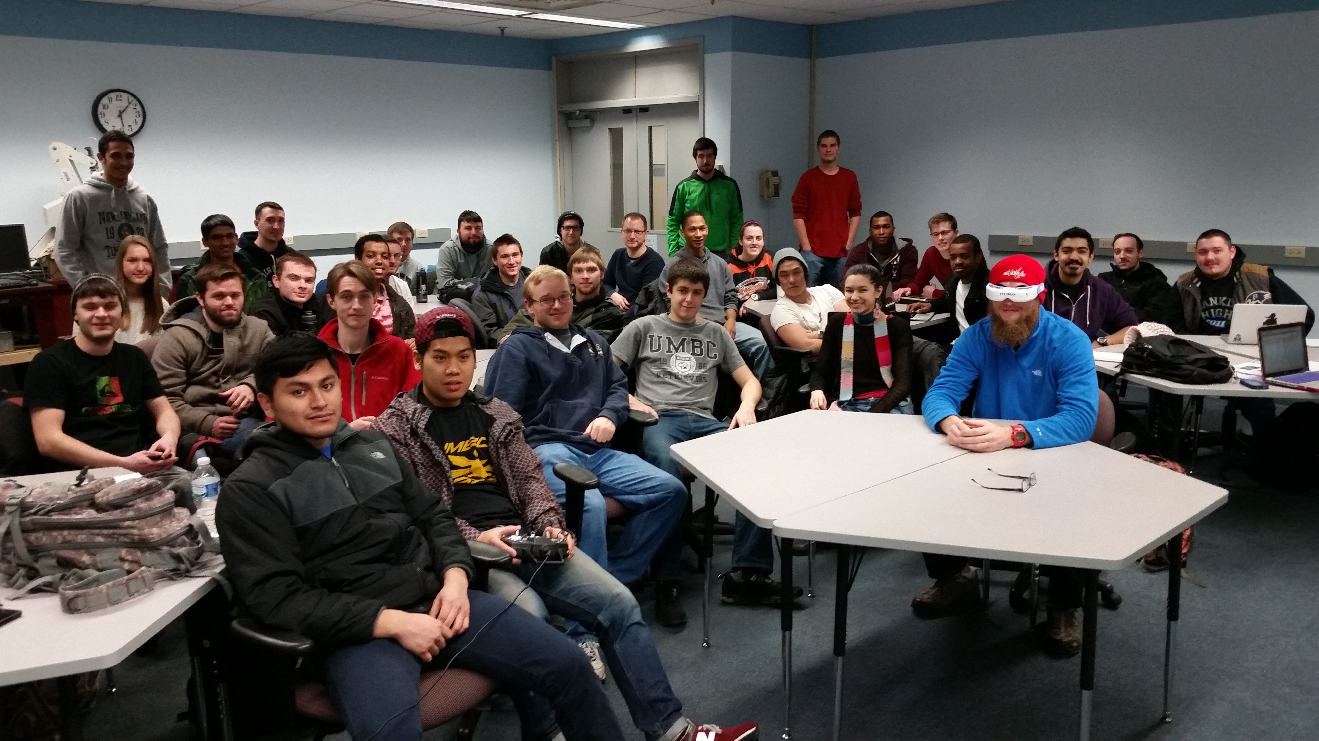](https://www.facebook.com/TheUAVClubofUMBC/photos/pb.1540691592868587.-2207520000.1423263509./1540695016201578/?type=1)

The site is currently down but will be up shortly. A link will be posted on the UMBC group page when it is up and running again.

Crowd Funding for Donation