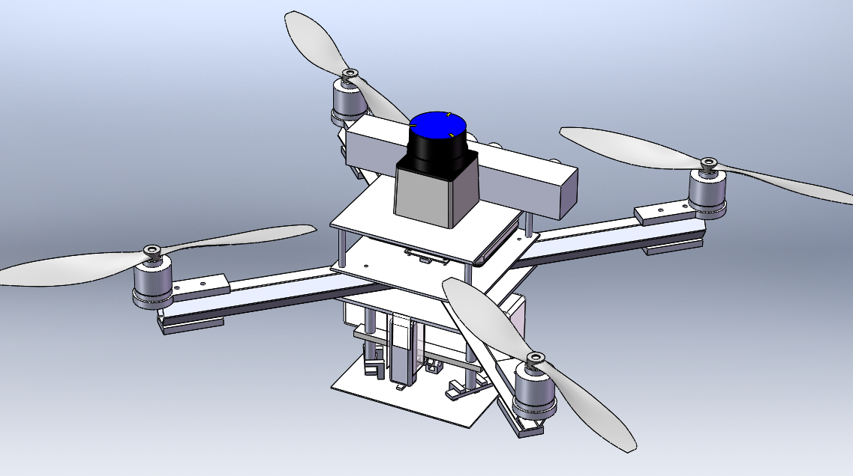

Note: Schedule is subject to change.

Ladies and Gentlemen,

Despite the abrupt change in schedule it was great to see that many of you could make it. In Fridays’ meeting a possible UAV competition in conjunction with IEEE was introduced by Timothy Barbour. We will be discussing whether to participate in this competition in the next meeting. We may have a speaker from the IEEE to inform a little more of the competition.

The obstacle course competition is currently being organized by Evan Shebel, Francios Rice, and Michael Warren who are working on design and finding a storage place for the obstacles.

We are still in need of volunteers for our booth at TAU Beta Pi’s “Engineering Demo Day.” As of now, there is currently no one in the 11am time slot. If you are available to help, please contact Stephanie Der or Shain Karambelas.

The Aberdeen Proving Ground Facility tour on February 13th has been postponed. You will be notified when a new group tour has been scheduled.

New Members,   
Please see Benjamin Cordell about joining one of the three teams and let him know if your commute is an hour or more north of UMBC as there is a team specifically designated for long distance commuters.

Club Meeting- 12:00- 1:00 p.m. - ENGR Room 112

Engineering Demo Day- 11 a.m.- 2:00 p.m.- Mainstreet

Feb. 24

Feb. 18

Feb. 11

Feb. 25

Engineering Demo Day- 11 a.m.- 2:00 p.m.- Mainstreet

Club Meeting- 12:00- 1:00 p.m. - ENGR Room 112

Club Meeting- 12:00- 1:00 p.m. - ENGR Room 112

### Upcoming Events

# State of the Club Address

Volume 1 Issue 2 February 9, 2015

Weekly Newsletter

UAV Club

Spring 2015

Ryan and Evan have drafted two fantastic logos/emblems. We will be looking to finalize these designs in the upcoming meeting. If anyone has a design they would like to share or an improvement on an existing design, contact Andrew Lee or bring your design to the next meeting.

[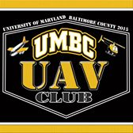](https://www.facebook.com/TheUAVClubofUMBC/photos/pb.1540691592868587.-2207520000.1423263509./1540695016201578/?type=1)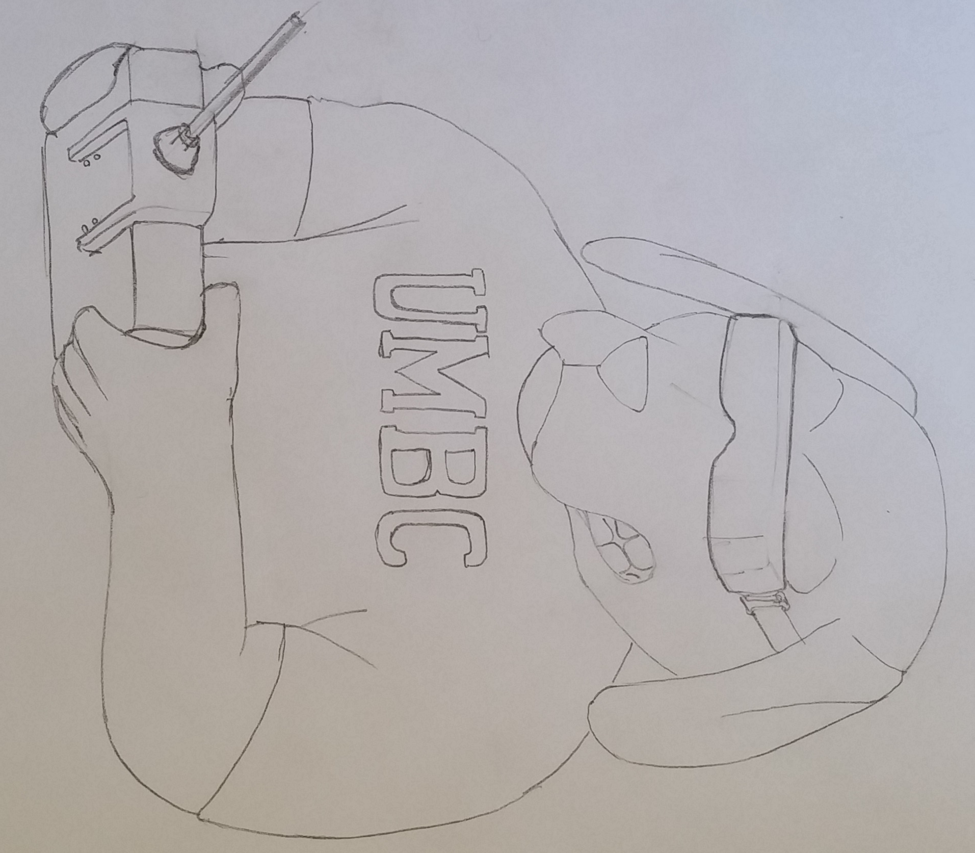

Finally, Ryan Henderson was gracious enough to create a Facebook page for us. Please join the group at [www.facebook.com/TheUAVClubofUMBC](http://www.facebook.com/TheUAVClubofUMBC)!

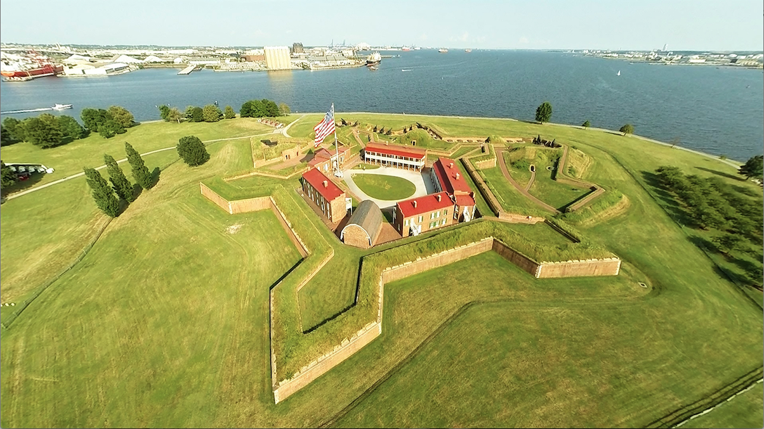

Courtesy of John Kraft

The site is currently down but will be up shortly. A link will be posted on the UMBC group page when it is up and running again.

Kick Starter Donation