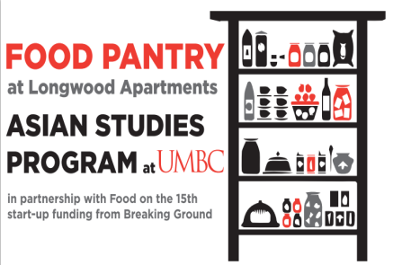
NON-PERISHABLE
FOOD DONATIONS
NEEDED!

Suggested Items:
- Canned tuna
- Spam
- Ramen and any type of Asian noodles
- Canned fruit (in its own juice)
- Soups
Look for the red donation boxes in:
- Commons: by the reception desk
- Admin: by elevators on 1st floor
- RAC: by front desk
- UC: across from main entrance
- Library: right side as you walk in
- Shriver Center: inside their office

The Food Pantry for low-income Asian senior citizens is sponsored by the Asian Studies Program and is staffed by ASIA 399 interns. This project (started through a UMBC BreakingGround grant) seeks to support low-income Asian senior citizens at the Longwood Apartments in Columbia, MD by collecting and delivering non-perishable food to them. The number of people served by our program has increased by 400% in one semester -- from 20 to 90 residents, which means we need even more donations!

Contact Julie Rosenthal at julier@umbc.edu, 410-455-2094 for info about internships and donations.

FOOD DRIVES ARE CONTINUOUS
Please donate as often as possible and please consider holding a food drive for us at your holiday party!

