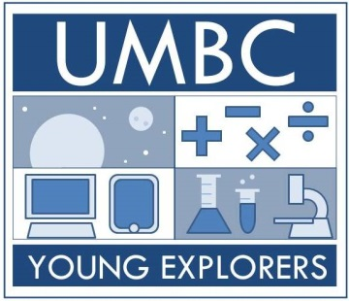
2016-2017 Young Explorers
After-School Fellow Application

UMBC Young Explorers provides out-of-school time programming for 1st-4th grade students who attend Lakeland Elementary Middle School.
During the academic year, we follow the 21st Century Community Learning Center program model, which consists of 30 minutes of homework help, 60 minutes of academic instruction, and 60 minutes of enrichment for 25-weeks. Young Explorers focuses on Reading and Math skills during the academic hour and STEM during the enrichment hour. The program begins around early October and ends around late April. Our goal is to provide a safe, nurturing, engaging environment for children, and we strive to strengthen parent and community involvement in the year-round achievement of their students.
We serve students who are academically struggling, especially in reading and math. Many of our students are non-native English speakers, predominantly from Central America. Most of our students are from low-income families. All of our students – and their families – want to be successful.
This is a paid Fellowship!
Fellow Responsibilities include, but are not limited to:
- Primary Responsibilities:
  - Facilitate the 30-minute homework help and 60-minute enrichment blocks of academic activities
  - Establish and maintain front-line care and education of program youth
  - Maintain assigned classroom space, which we borrow from teachers
- Shared Responsibilities:
  - Lead any community meetings, assist and/or lead enrichment activities, and chaperone field trips
  - Oversee volunteers (i.e. transportation, schedule, attendance) and attend Shriver Center site leader meetings
  - Actively participate in community engagement & service learning activities, program meetings, and all Young Explorers training workshops and reflection meetings
- Must be available on the following dates: Because of inclement weather and consequent school year calendar adjustments, these dates are subject to change.
-- October 7th late afternoon/early evening AND October 8th all day: Program Orientation and training at UMBC
-- October 10th-December 19th and January 3rd-April 21st , except BCPS spring breaks
-- Monthly meetings TBD in consultation with Fellows

Please complete the following application and return it to Mr. Zach Pekor via email at zpekor@umbc.edu or in Room 724 Administration Building by September 12, 2015.
Applications are due NO LATER THAN 5 p.m. on Monday, September 12th, 2015.
Interviews will be conducted between September 19th and 21st.
Selected fellows will be notified by September 22nd with your response to the offer required by September 28th.
Full Name: Academic Standing (Year):

Cell Phone Number: Email Address:

What is the best way to get in touch with you?
Please indicate your availability for a 30-minute interview during the week of September 19-21 by listing ALL days and times you are available between 9:30am-5:30pm.

ACADEMIC INFORMATION
College/University you attend(ed): Graduate Program in which you are enrolled, if applicable:
Undergraduate Major: Declared Minor, if applicable: Cumulative GPA:

Have you taken any education or child development courses?
(check appropriate box) Yes No
If yes please list:

Have you participated in any leadership development/training courses, workshops, seminars, conferences etc.?
(check appropriate box) Yes No
If yes please list:

SHORT ANSWER QUESTIONS
Please answer the following questions briefly AND in a way that allows us to get to know you, your aspirations, and your motivations. We use these questions to determine whether or note we will interview you!
- What motivated you to apply for this position?

- Describe your future goals. How would this experience support those goals?

- You will be working with urban youth from low-income families who attend Lakeland, which is a Baltimore City School. What most excites you about this opportunity?

