$600 SUPPORTS ONE ORPHAN FOR AN ENTIRE YEAR.
WHY DO I CARE, AND WHY SHOULD YOU?
I care about these orphans because if it weren't for people like you and me who can raise money to support them, they would be a lost generation. I am so grateful and blessed for being born in the US and never having to question if I can afford to go to school and if my family thinks that best for me. I am blessed to have a family that supports me. I have never had to go hungry, have too few clothes, or feel dirty and go for days without a shower. Much like the founder of the organization, Terry, I agree that because I have the power to help these children, I MUST do my best to help them. The wonderful children I have met who are getting help solely because of this organization--they would not have a chance at an education, breaking the cycle of poverty, and empowering themselves, especially the girls.


I wholeheartedly believe in this organization.

WHAT IS THE SHAMBALA FOUNDATION?
www.shambalafoundation.org
SF is a Norwegian nonprofit organization that operates in Xining, Qinghai Province, China, which is also in the local of Amdo Tibet. Their mission is to alleviate childhood poverty in Asia. They currently support over six hundred orphans in Amdo, Tibet, and are planning on expanding their programs into Burma soon. Their main project is Orphanage Without Walls (OWW) which ensures that the orphans are getting an education and that they and their families have their basic needs met, such as food and clothing. SF has six hired Tibetan social workers (who are fabulous!) who meet with the children on a yearly basis, driving out into the grasslands to each family and often having to convince the families to enroll their children in school rather than a monastery (boys), or not enrolling them at all (girls). SF focuses their attention on girls to empower them out of poverty and give them an equal opportunity at achieving an education. SF also does several small-scale projects and is currently developing their own English and vocational training school so that these orphans could complete their public education and then enroll in this vocational school to receive intensive English training and master a vocation of their choice.

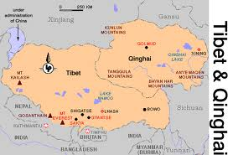

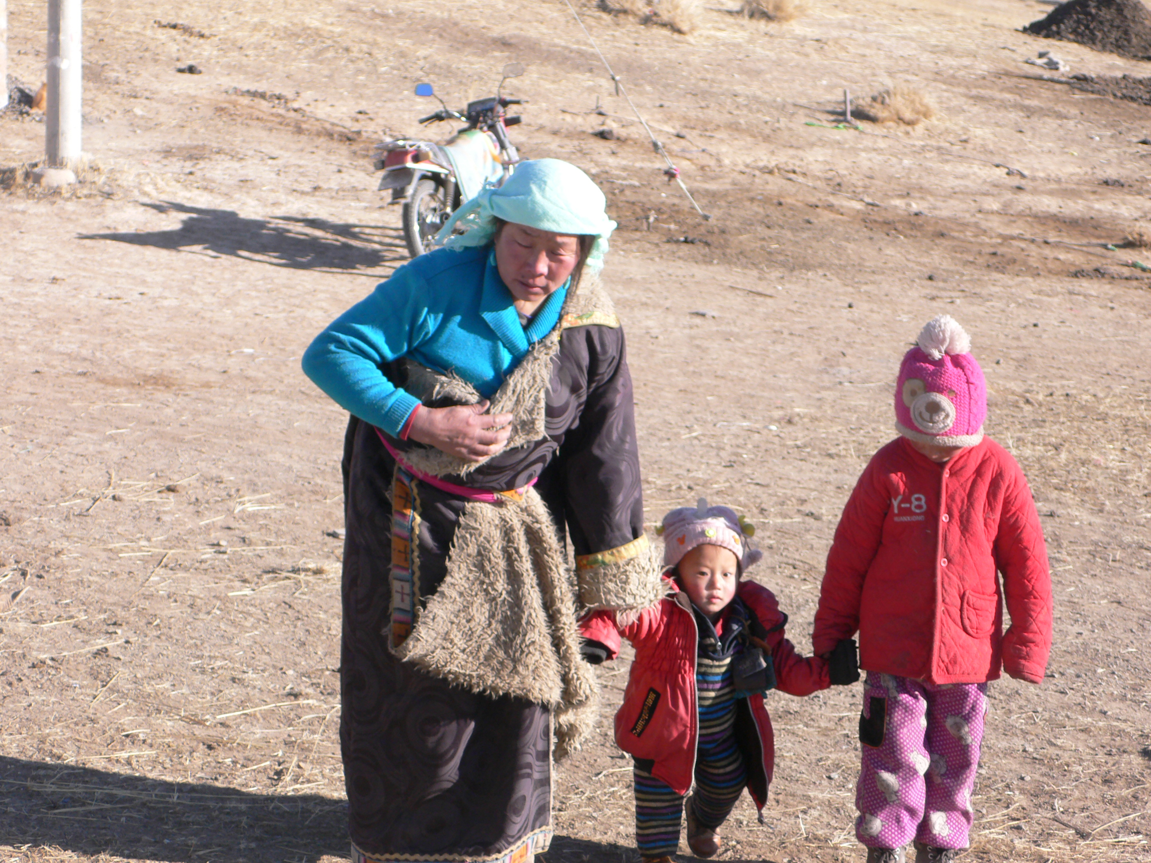

WHAT'S THE HOLIDAY CAMP?
I learned all this information mostly on my trip in January when I was invited to meet the organization which was timed during SF's annual Holiday Camp. We went into the grasslands to pick up fifteen orphans at a time. Each week fifteen children are invited to Xining, the capital of Qinghai Province, for a fun and educational break from their difficult life. The first thing the children do is take a hot bath because life in the grasslands is not sanitary and the children are often covered in dirt and dust when we first pick them up. The second most important event is getting them a hearty and healthy meal. Then every morning the Tibetan staff give classes to the children (in Tibetan) then the children are taken on a daily excursion—I went with them to the zoo and the Tibetan Medicine Museum. For many of these children they have never been to a big city, cannot speak Mandarin, and are of course unfamiliar with urban Chinese life. It is a wonderful experience for the children (and incredible for me as well!!), and seeing their beaming smiles makes it worth it.

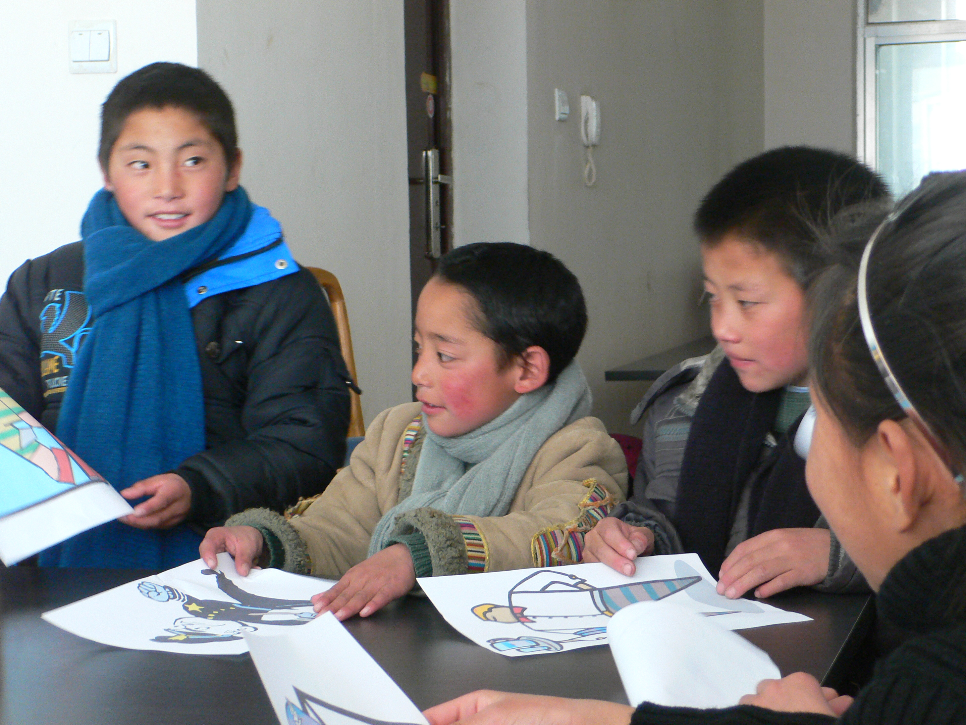

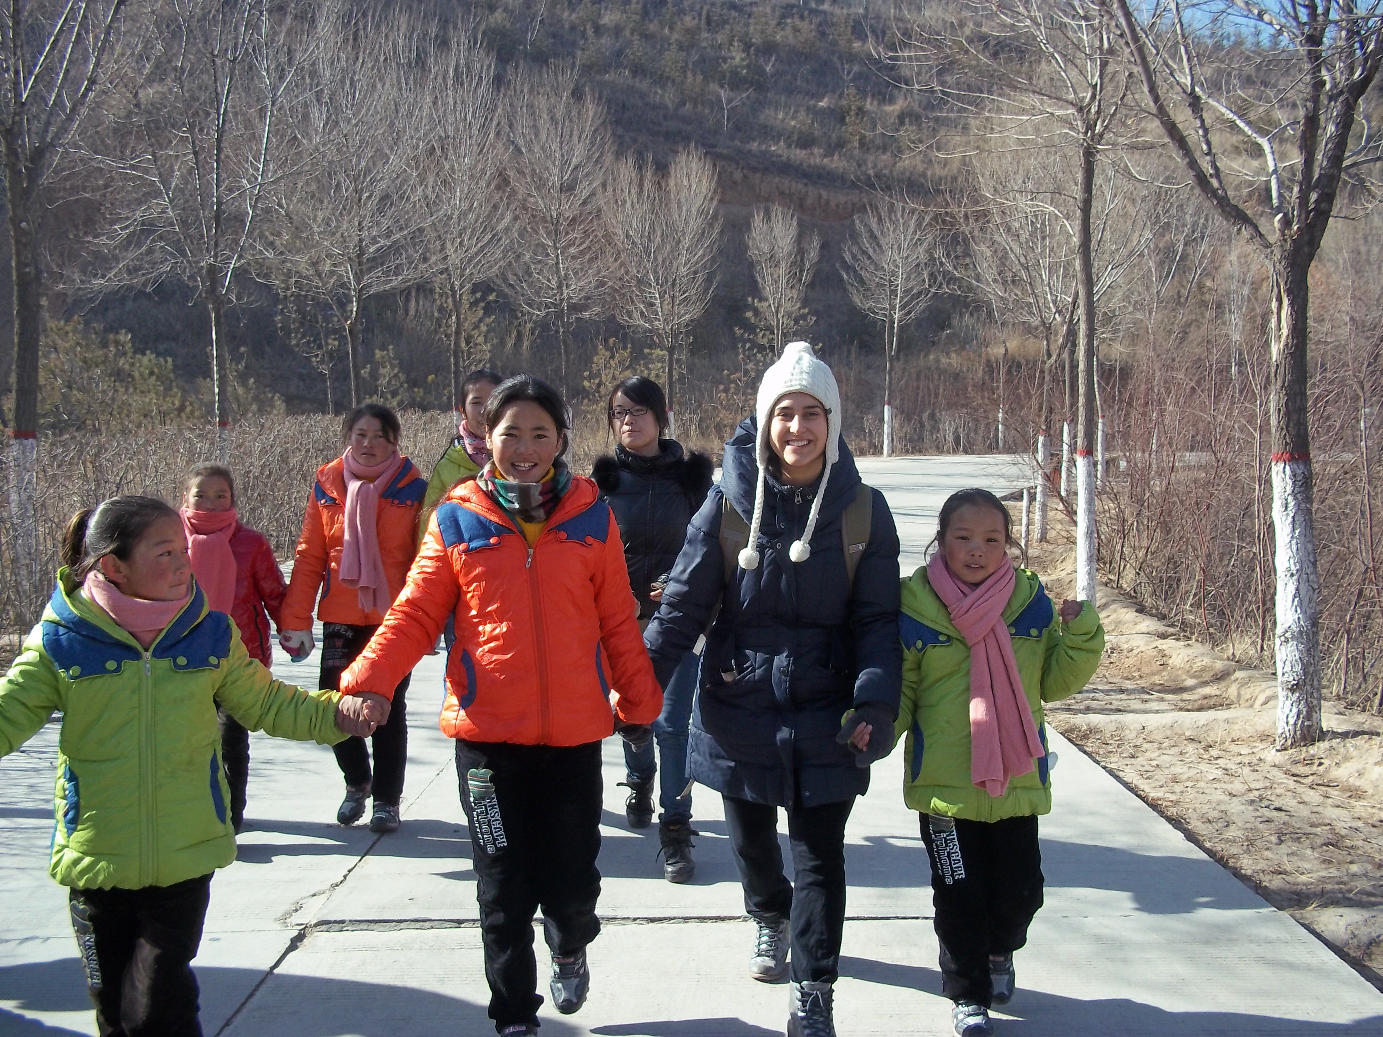

WHO AM I? WHAT IS UMBC SHAMBALA?
My name's Yasmin. I am an Asian Studies major and senior at University of Maryland, Baltimore County (UMBC), and I spent my winter break in Tibet visiting a small non-profit organization, The Shambala Foundation, who has offered me their fellowship position for next year. Last semester I started a student organization at UMBC called UMBC Shambala. We are a student club that raises funds for SF's orphan sponsorship program. Our club members include Niki, Sara, Dot, Marina, Summer, Devin (Lady Devon, haha), and Kelsey. We are dedicated to helping this wonderful children break the cycle of poverty and empower them and their communities! To raise funds, we hold awesome events like music benefit shows, parties, cooking classes, bake sales, and we are currently planning a 5k marathon to be held at UMBC this spring. All the funds we raise go DIRECTLY to supporting the orphans.

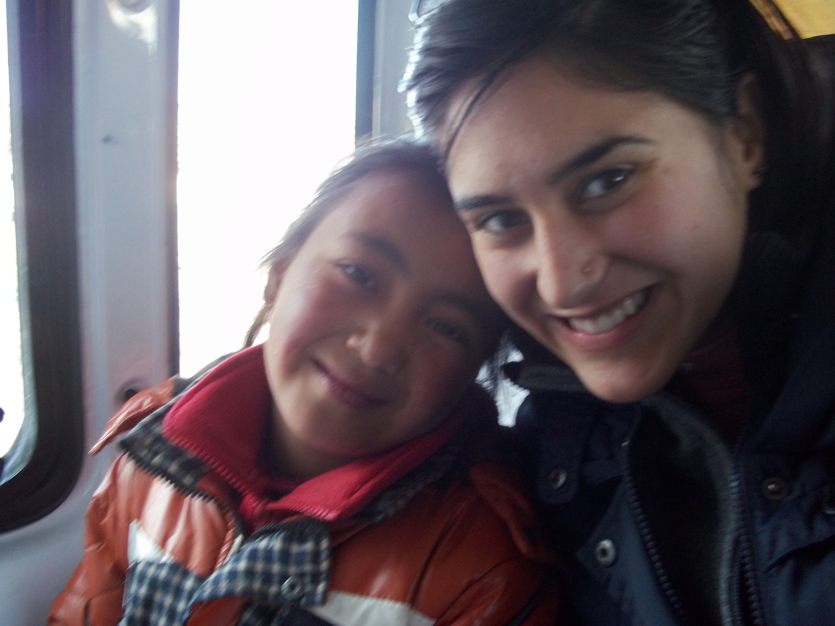

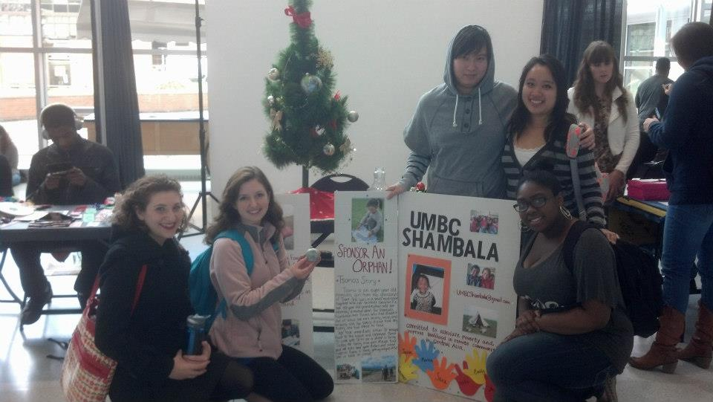

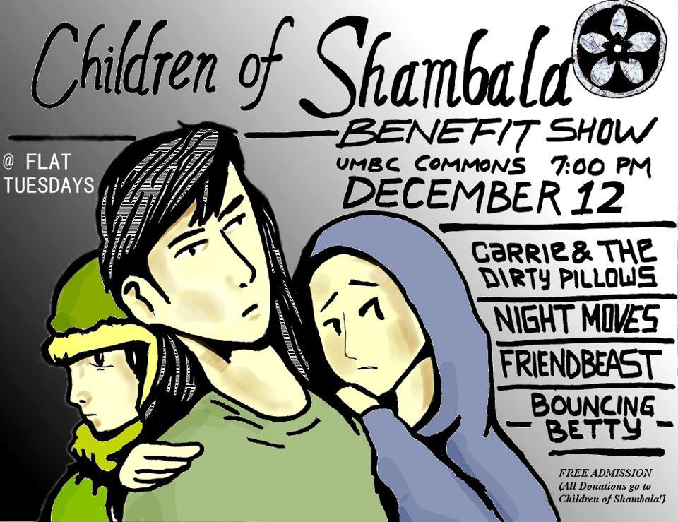

HOW ELSE CAN YOU HELP?
If you can't donate funds here, ORGANIZE YOUR OWN EVENTS! Email me at radbod1@umbc.edu for any help or questions you might have about how to organize events, how to fundraise, or any questions you have about The Shambala Foundation. I would love to help you start an organization at your school or help you start a community organization in your community!
Peace and Love! -UMBC Shambala

