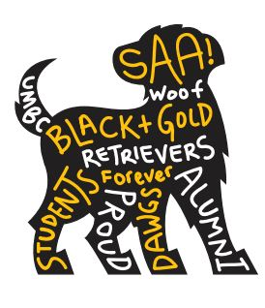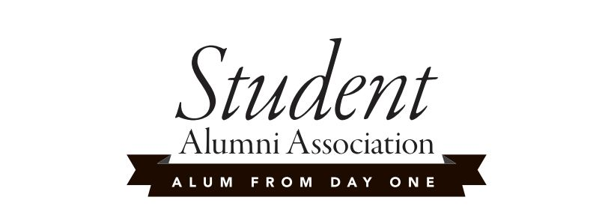

**Member Updates and Check-Ins Wed 8/28/2013**

**SAA “How I Met Your Org” Video Shoot Today!**

**Group and Event Updates**

* Fall Involvement Fest Wed 9/4 from 12-3 on the Quad.
  + Volunteers?
* UMBC DYE HARD (Rano and Sheena) Wed 9/11 at 7:00 pm in Erickson Courtyard
  + Event volunteers (set up, smores chef, music / playlist dj, take down)
  + True Grit Mascot
  + Fliers, Facebook, and myUMBC
* Google Docs – SAA Roster and Attendance
* New Event – True Grit’s Birthday Party?
* Kevin’s Update

**SAA Changes for Discussion**:

SAA – A premier student leadership position on campus with direct ties to UMBC Alumni networks and exclusive opportunities. This group is open to all current UMBC students who have an interest in leadership, professional development, networking with UMBC alumni, creating a vibrant on-campus community, and preserving UMBC spirit and tradition.

Admission into SAA provides many unique opportunities on campus. In addition to hosting several fun social events throughout the year, SAA members have exclusive access at alumni and institutional events including Homecoming and Commencement.

Rebranding Possibilities for Discussion:

* + New logo - 1) clean and polished banner logo or 2) young and fresh dog logo 3) both?
  + Re-claim “Alum From Day One”
  + GPA Requirement - 2.0, 2.5, 3.0, 3.5
  + Application Process : 1) complete online application and 2) interview with Jess and an officer
  + Lifetime membership
  + Limited to 20 active members
  + Create a “Director of Member Relations”
  + SAA Speaker at Commencement?
  + SAA + Freeman Hrabowski
  + What else?

**SAA Marketing Updates:**

* SAA Video Update (Jasmine and Mike)
* MyUMBC SAA Group: [my.umbc.edu/groups/saa](http://my.umbc.edu/groups/saa)
* Recruitment Initiatives: (Mike and Jess)
  + Active Marketing:
    - Goal: low cost and high impact!
    - Recruitment social in two parts

1) UMBC DYE HARD – food, fun music, distribute SAA invitations, pictures w/ True Grit

2) Casino Night OR SAA Interest Meeting? (Stephanie, Matt, Jasmine)

* + - Technology
      * iPads at events to check-in students and “Like SAA” on Facebook
    - Freebies – Frisbees, t-shirts for kickball
  + Passive Marketing:
    - Campus fliers
    - MyUMBC Spotlight, iNet
    - December - Finals SAA Well Wishes (Mike)
  + Reach out to: First year students, established student leaders including UMBC Admissions Ambassadors, RSA, SGA, Phon-A-thon, Phi Kappa Phi, LeaderShape, etc.

Q: Who else?

* + Get recommendations from Faculty and Staff - send Jess to the Faculty and Staff Senates

**Upcoming Events**

Event Date / Time / Location Chair

Fall Involvement Fest Wed 9/4 12:00-3:00pm on the Quad Jess

UMBC DYE HARD Wed 9/11 7-9pm in Erickson Courtyard Rano & Sheena

SAA Casino Night / Interest Meeting Wed 9/25 7-9pm in Flat Tuesdays Stephanie & Jasmine

Homecoming Kickball Kup Sat 10/12 1-2:30pm in Erickson Field Jasmine & Matt

Life 101 Wed 11/6 6-8pm in UC 310 Stephanie & Kevin

December Finals Well Wishes TBD Mike

**Upcoming SAA Meetings** – Fall 2013

Bi-Weekly on Wednesdays from 12:00 noon - 1:00 pm

8/28  Commons 332

9/11  Alumni House Conference Room

9/25  Commons 328

10/9  Commons 328

10/23  Alumni House Conference Room

11/6  Alumni House Conference Room

11/20  Commons 329

12/4  Commons 318