Thank you for your patience.
The Supplier form has once again been updated.
With this update the amount of frustration and back and forth with suppliers should be cut down significantly.
The firm name section has been changed to be Optional and should only be used for a business. Please see examples below for how to fill initiate the forms.
Individuals
What you will see as the initiator:
“**LEAVE BLANK FOR INDIVIDUALS**” is only written as a reminder and should not be written into the form.
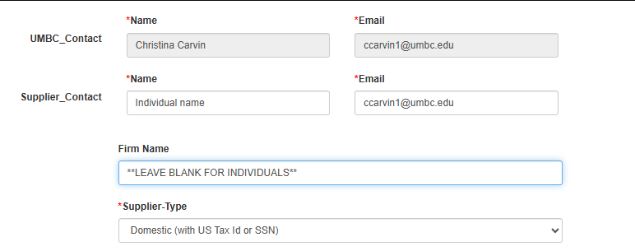
What the Supplier Sees:
Individuals should leave the firm name blank.
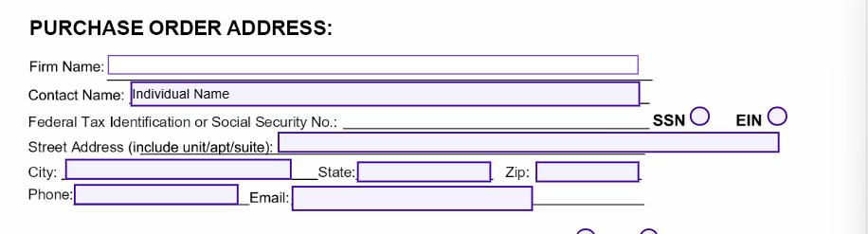
Individuals should leave line 2 of the W9 Blank. 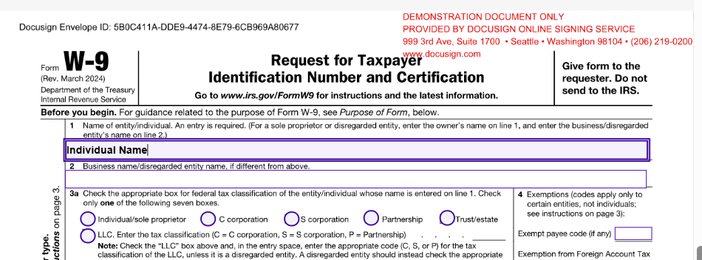
Business
What you will see as the initiator:
Firm name should be used for Businesses only. Please enter the business name in the Firm name Field. And the person of contact in the Supplier Contact field.
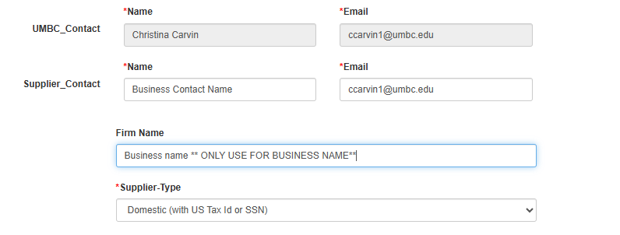
What the Supplier Sees:
The supplier should not have to enter any information in the supplier form fields for Contact name or Firm Name as the information was auto populated from the fields you entered as the initiator. However, they can edit the fields of Firm Name or Contact Name if something is incorrect.
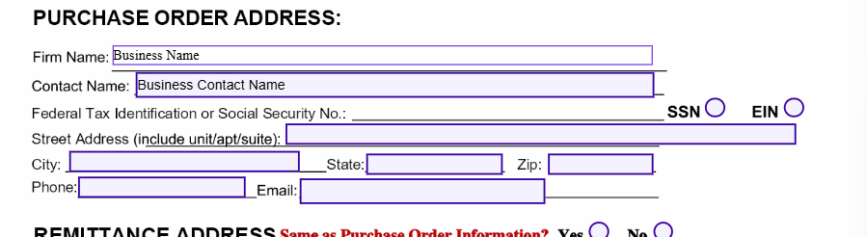
As for the W9 we still cannot accept W9s with the same information in Line 1 and Line 2.
If they are a business their name. The following are all acceptable ways for the company to fill out the W9 form fields 1 and 2.
Option 1
Owners name in line 1 – Business/Company name in line 2
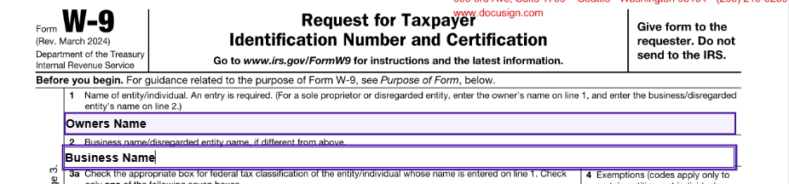
Option 2
The Corporation name example :ABC CORP in line 1 and the DBA name in line 1
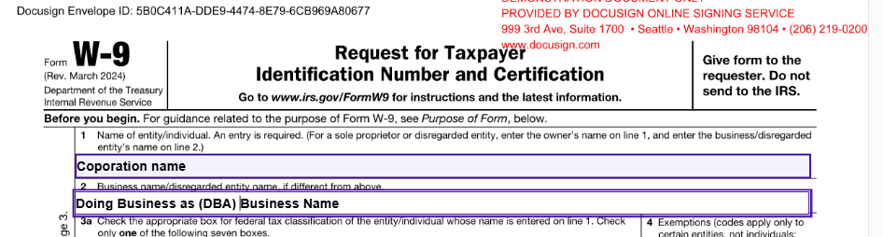
Option 3
Just the business name in line 1 and line 2 is left blank.
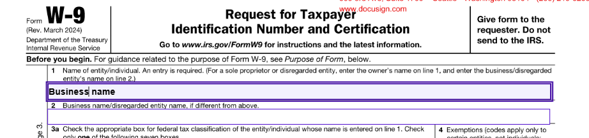
Thank you once again for your patience while we resolved this issue with the Docusign form.
UMBC Procurement
November 2025

