|  |  |
| --- | --- |
| February | 2014 |

Media and Communication Studies Council

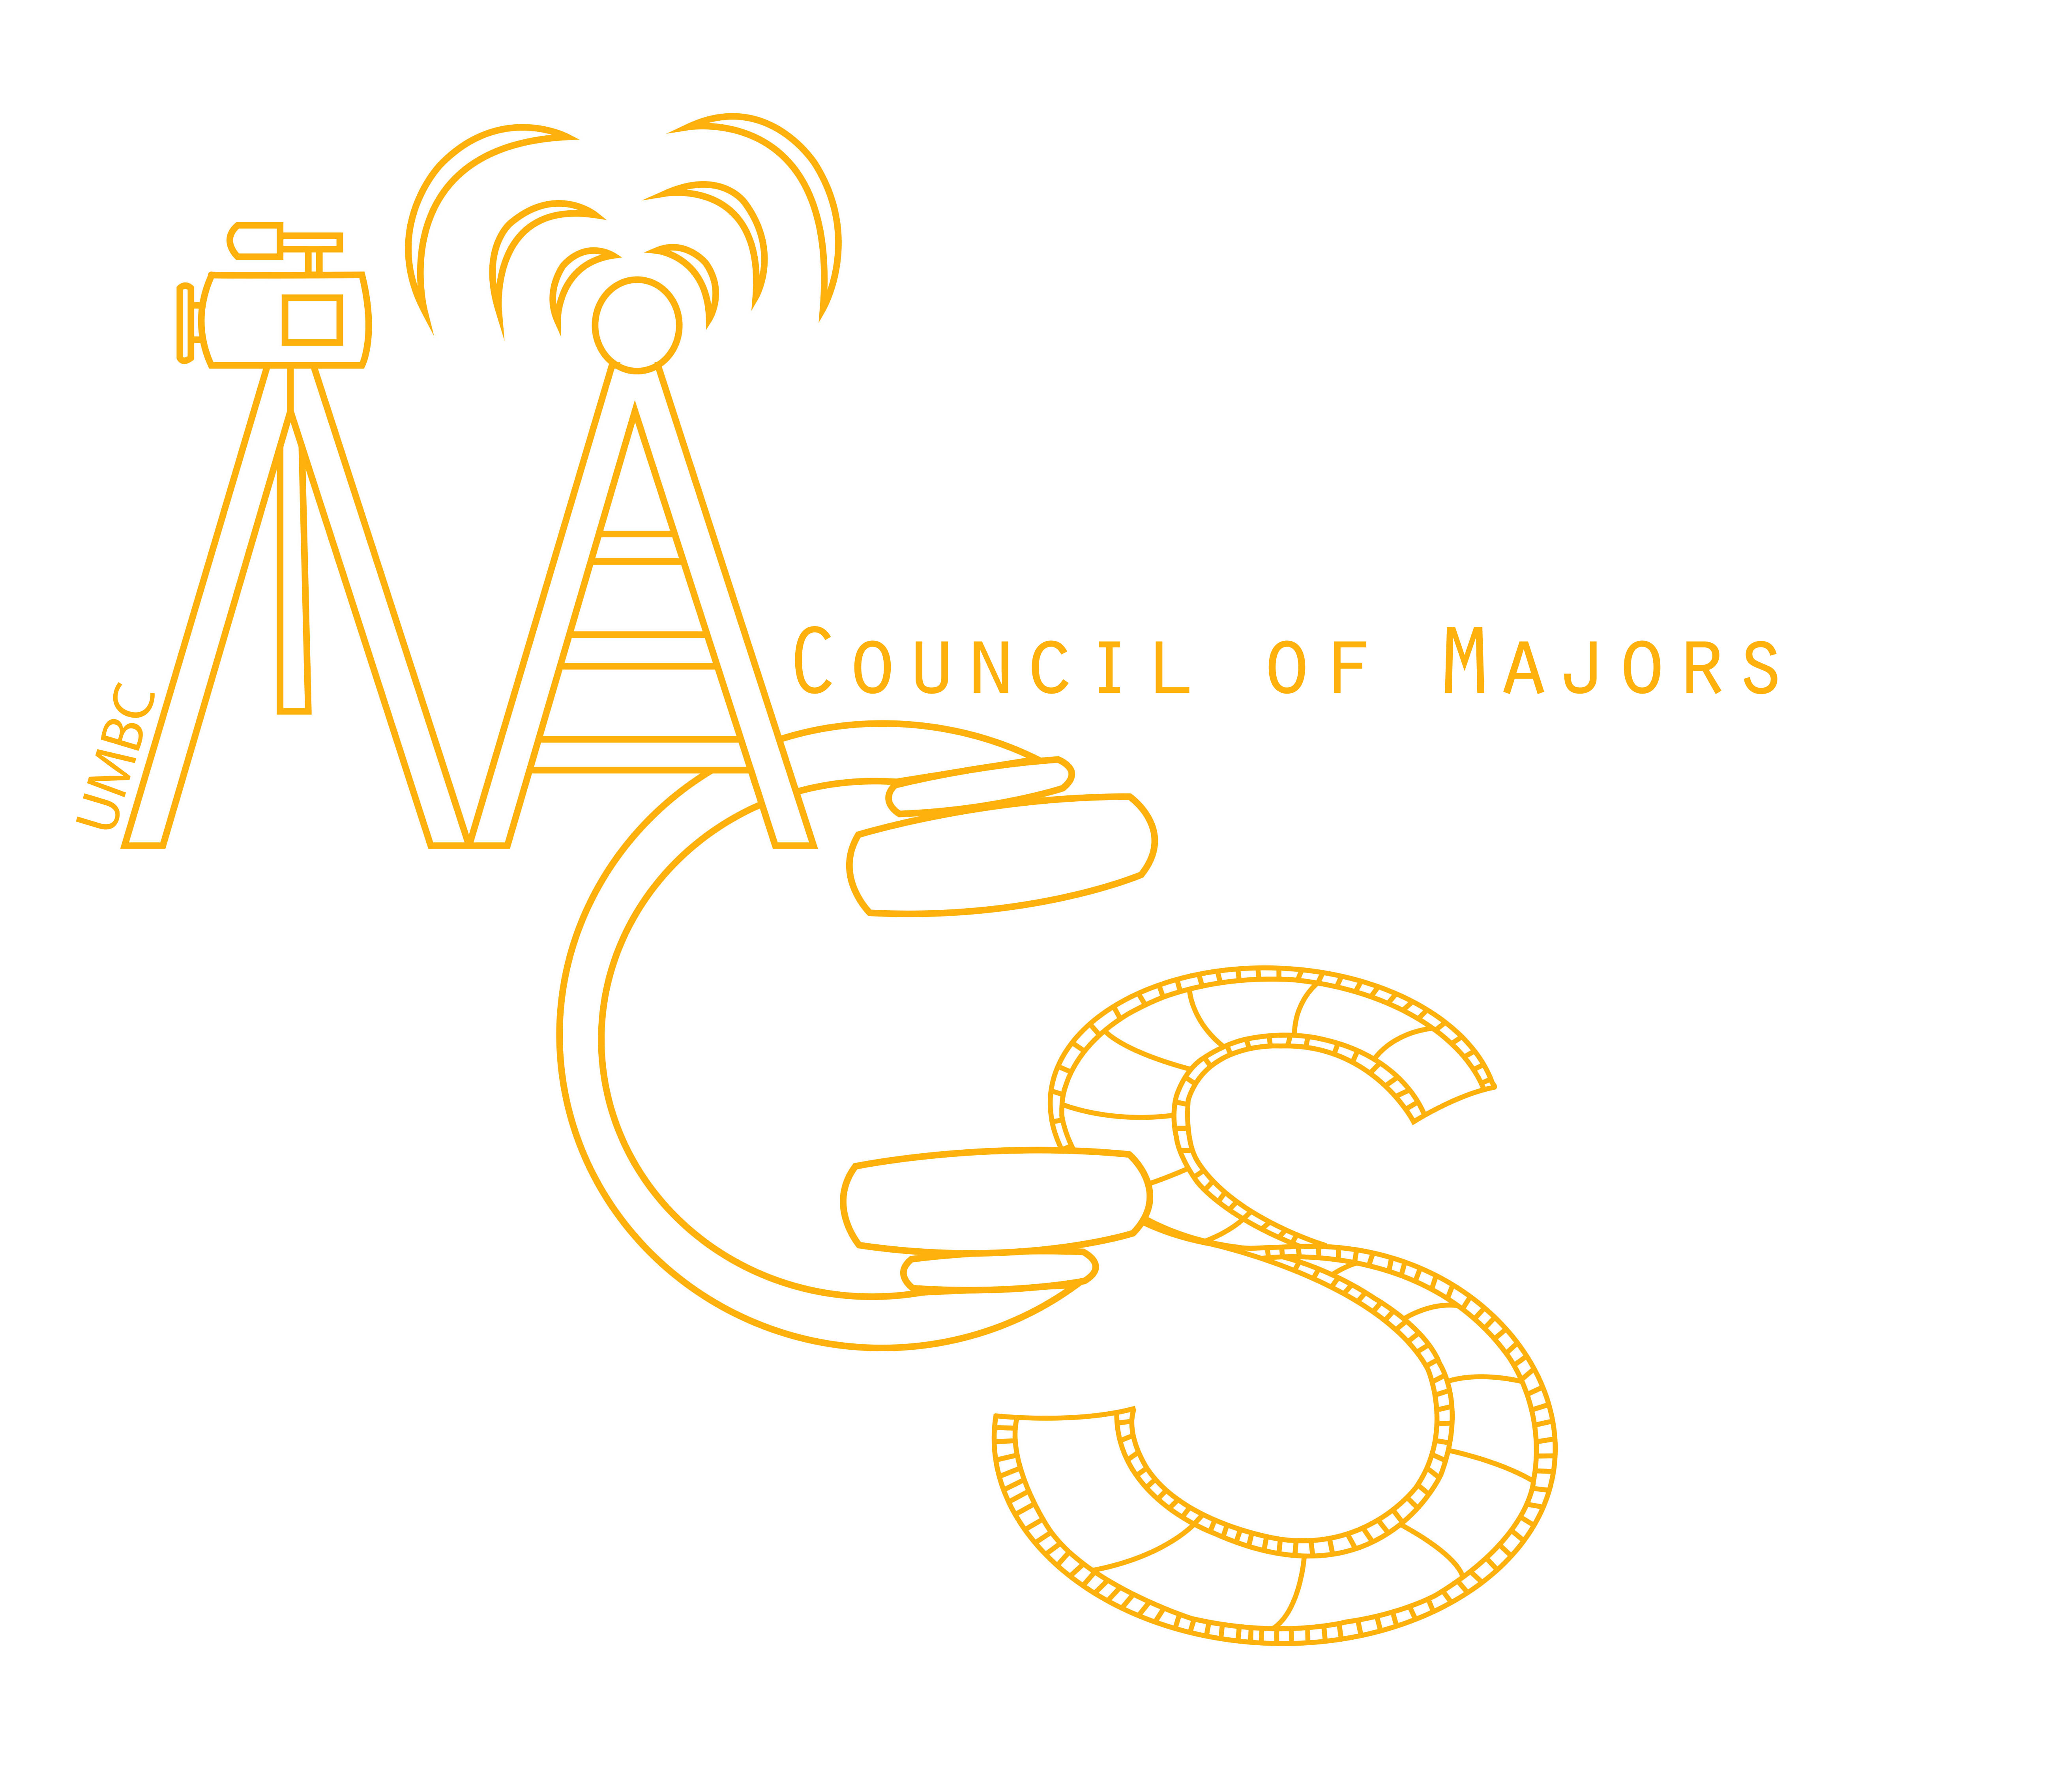

|  |  |  |  |  |  |  |
| --- | --- | --- | --- | --- | --- | --- |
| Sunday | Monday | Tuesday | Wednesday | Thursday | Friday | Saturday |
|  |  |  |  |  |  | 1 |
|  |  |  |  |  |  |  |
| 2 | 3 | 4 | 5 | 6 | 7 | 8 |
|  |  |  |  | Meeting  12:00pm-1:00pm |  |  |
| 9 | 10 | 11 | 12 | 13 | 14 | 15 |
|  | Departmental Meet and Greet!  12pm-1pm |  |  | Bake Sale and Short Meeting  11am-3pm |  |  |
| 16 | 17 | 18 | 19 | 20 | 21 | 22 |
|  | Meeting  12:30pm-1:00pm |  |  | Meeting  12:30pm-1:00pm |  |  |
| 23 | 24 | 25 | 26 | 27 | 28 |  |
|  |  |  |  | Bake Sale!  11am-3pm |  |  |
|  |  |  |  |  |  |  |
|  |  |  |  |  |  |  |