

A Change is Coming... PageUp is getting a New Look.

Phase 4 – Applicant Card
Release Date: July 3, 2019

PageUp continues updating their interface to meet the changing needs of their customers. This month, PageUp has made some significant upgrades to the flow of the applicant card.
What is changing?
The applicant card has a brand new look. All of the same features are still available but may have moved to a different place on the card. The new applicant card utilizes tabs to find information instead of scrolling down the page.

The applicant card currently looks like this:
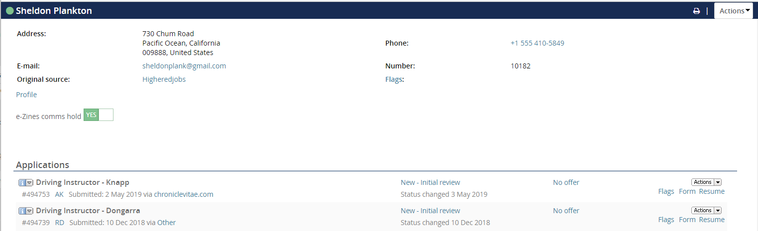

The new applicant card is scheduled to go Live on July 3, 2019 and will look like this:
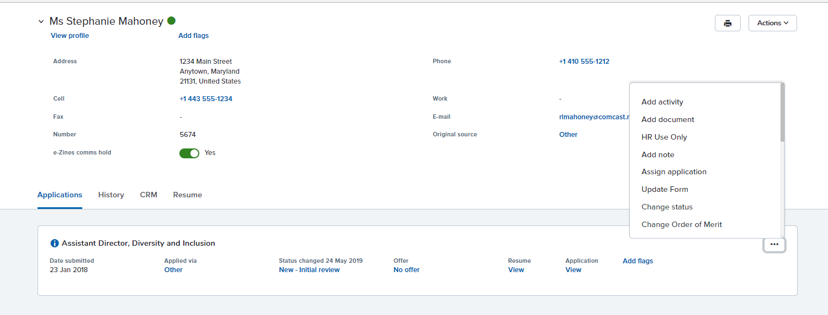
Former Actions Menu
Click the 3 dots to open
Click here to upload Justification memo, communicate, or send online references

Tab Format

Applications Tab

The various functions within this tab have been spread out and are easier to view and access through hyperlinks.
The Action tab has been replaced with the symbol 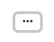From this symbol you can upload your justification memo, communicate (send e-mail) to candidate, add a note to their file, etc.

The application form can be accessed by clicking on the blue hyperlink “View” under the word Application. The resume will be located at the bottom of the application form.
You can access the Offer Card by clicking on the blue hyperlink under the word Offer. It will say “No Offer” until you have moved the candidate into Create Offer Card and Route for Approval status, at which point, the hyperlink will change to Offer Card.
Flags can be added by clicking on the blue hyperlink “Add flags”

Filter by Job and/or Item
History Tab
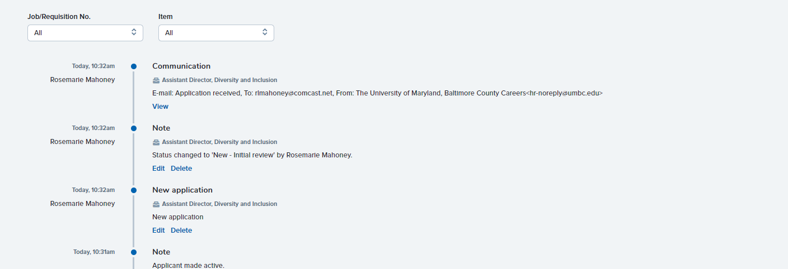
View contents of e-mail sent
Item in bold

The History tab contains all the status changes, documents and communications that have occurred during the candidate’s recruitment life cycle. You may filter by job and then by Item to narrow your search.
The format is designed to be easier to view and access the information that you need. For example:
- Each item (Note, Communication, Document etc.) headlines the History event and is in bold.
- The View/Delete links are now located right under the item to make it easier to locate.
- In addition, the information is spread out and easier to read as a timeline.

Note: Additional changes to the HR Liaison dashboard and Search Committee screens will continue over the upcoming months. Human Resources will send out notices of the changes as each navigation screen is implemented.
HR 6/19

