Cover Letter Etiquette
Your contact information in this area

The date

Their contact information comes after

Before Writing:
Read carefully the qualifications they’re looking for and write down the bullet points. Align your cover letter addressing them with your previous experience. Make sure to read the overarching goal/mission/purpose of the organization; you will need this for the conclusion or introduction depending on your style.

Introduction:
Open with how you heard about the position – if you were referred by someone, definitely mention that – and then state (briefly) how you are the most qualified and why you want to work there.

Body:
Describe how your previous experience/education relates to the position you are applying for. This should open with the most relevant experience first seeing as some employers only skim-read cover letters.

Conclusion:
Restate why they should hire you and mention some personal connection you have with their mission statement if you did not do so in the introduction. Thank them for their time; mention your resume/cv is enclosed and that you look forward to hearing from them.

Suggestions:
People make decisions based on feeling more than logic; appeasing their emotions by mentioning how this job is of personal interest to you can go a long way.

Stand-out: Most likely all the applicants have your qualifications. What is unique about you that you could include? One coworker passively mentioned hiking the Appalachian Trail in his introduction. Your volunteer work might be a nice touch. A friend of mine has a signature quote in her cover letters of “I have the dedication of an athlete, work-ethic of a farmer and patience of a teacher.” The point isn’t to be unnecessarily bold, but to stand out in some way. Maybe change the font you use.

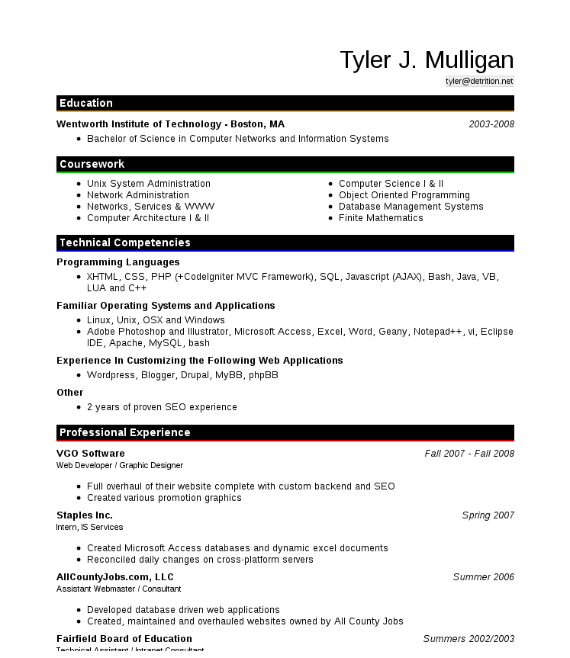
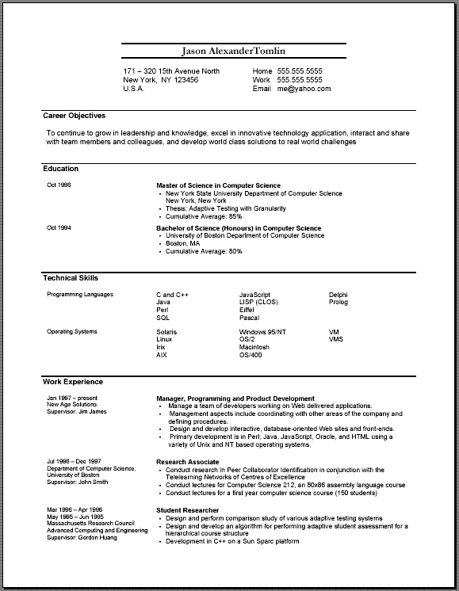
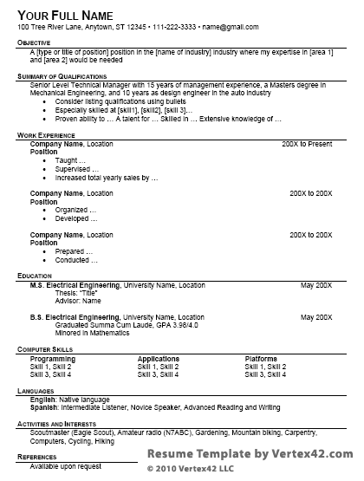
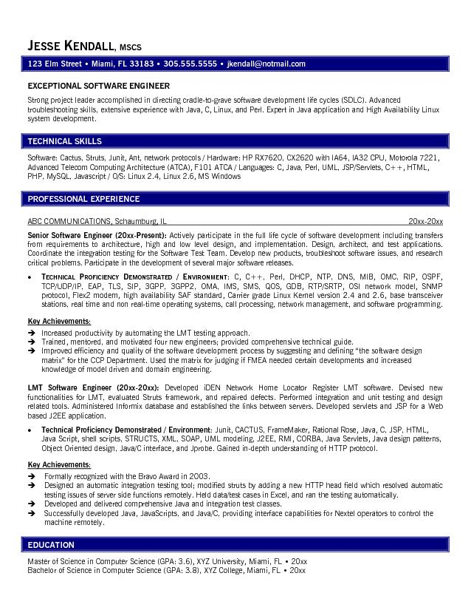
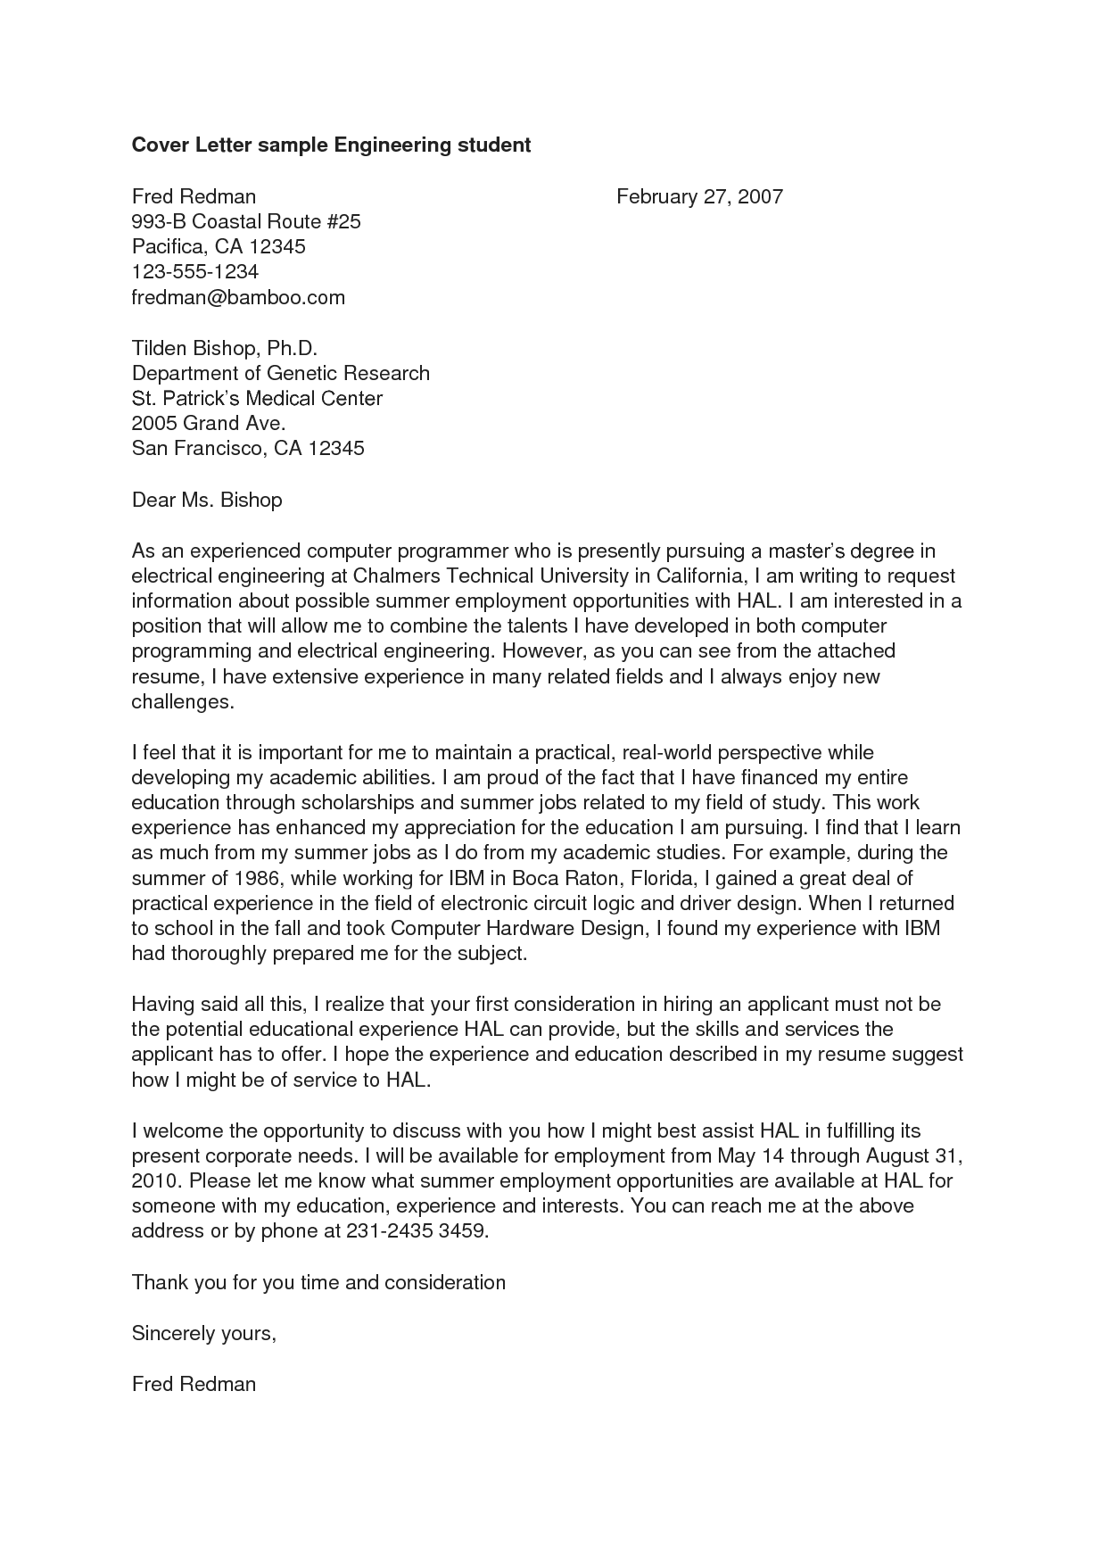
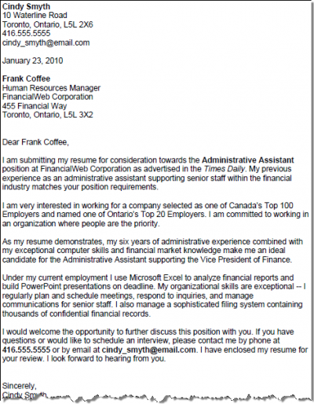

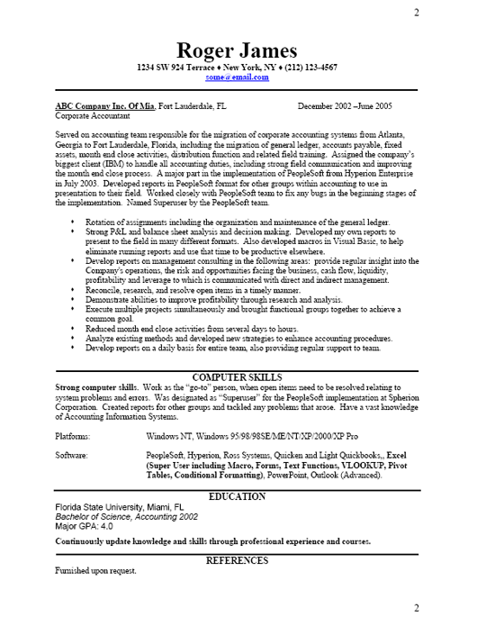

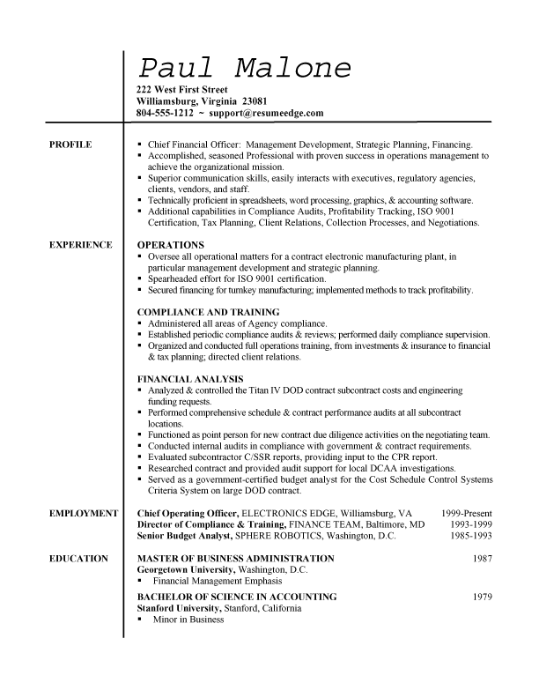
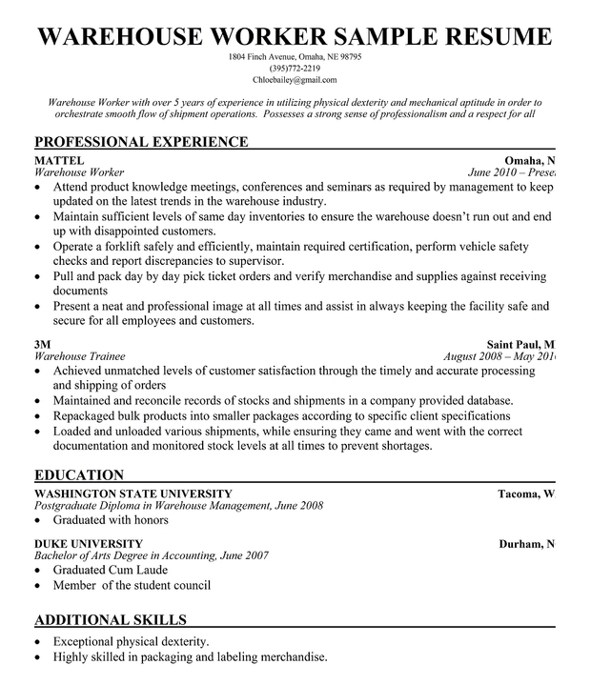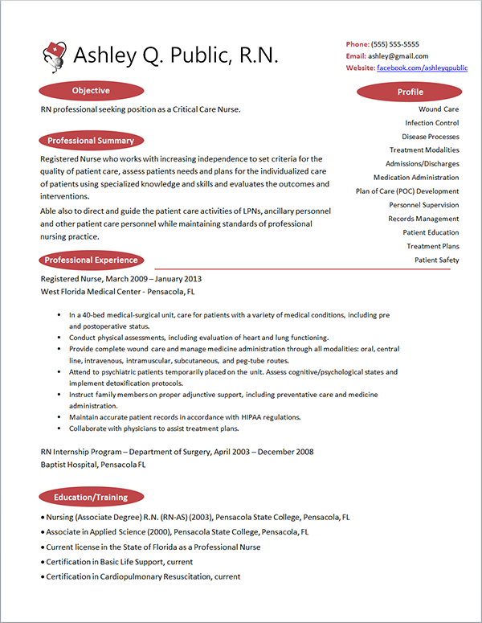

Stephanie Ward
9 Sandy Court
Halethorpe, MD 21227
410.829.9791
steph28@umbc.edu

25 June 2013

Jenness E. Hall. Ph.D., PCC, ORSCC
Executive Director
Whatever Association
hall@umbc.edu

Dear Dr. Jenness Hall:
I am writing to apply for the Community Liaison position within the Office of Graduate Student Life posted on UMBC works. I am an incoming graduate student and an UMBC alumnus excited to continue to serve the thriving UMBC community.

I am confident that my previous in-depth involvement and employment at UMBC provided me with the experience that will allow me to fulfill the responsibilities of this position in a creative and efficient manner. My role in the campus community is as high of a priority as my academic career.

I have learned the ins and outs of UMBC policies and the event planning process, particularly through my role as the chair of an LGBTQIA Leadership Conference, BMORE Proud, which took place on campus in February 2012. In this role, I managed a large $18,000 budget, requested donations, created a schedule of events, reserved multiple spaces on campus,worked with catering companies, followed-up on performer contracts, and coordinated many more logistical tasks.

In addition to my extensive event planning knowledge specific to UMBC, I developed the tools and passion for engaging the student body and facilitating communication between students, faculty, administration, and staff. My roles in the Student Government Association and The OSL Mosaic: Center for Diversity allowed me to practice pursuing many initiatives that supported student voice and diversity on campus.

I appreciate your consideration of my resume and application. I look forward to hearing from you about this position, as I am committed to continue to utilize my passion for student advocacy at UMBC. I can be reached through the e-mail and phone number listed above.

Best Wishes,

Stephanie Ward

July 3, 2013

Jenness E. Hall, Ph.D., PCC, ORSCC
Executive Director, GSA
The Commons 308
1000 Hilltop Circle
Baltimore, MD 21250

Dear Dr. Hall:

I would like to express my interest in the Community Liaison position with the Office of Graduate Student Life. My professional background in architecture, planning, and non-profit work all stems from an interest to engage people and strengthen communities. I am currently a Masters student in the Intercultural Communications program at UMBC. At this time I am looking to direct my studies and career towards community engagement and education, working with an organization that promotes community education as well as community vitality.

I have worked to implement a community relations group on the border of Baltimore County and Baltimore City as an extension of my responsibilities in the Strategic Planning office at Charlestown Retirement Community. Neighborhood organizations and institutions have come together with the intent of establishing common goals that enhance the quality of life in the greater community. I also served as Chair of the Diversity and Inclusion Council during my tenure at Charlestown. Lastly, I continue active membership and participation in the American Institute of Architects, writing a grant for CivicLAB, an educational series for young professionals in Baltimore that promotes opportunities for civic engagement in the built environment.

I hope to lend my organizational and planning skills to a position that focuses on supporting community goals and opportunities within an academic environment. I feel my background is a great fit for the needs of the Office of Graduate Student Life. Please find attached my resume. I look forward to speaking with you further about the opportunity to engage other Graduate students at UMBC. Thank you in advance for your consideration.

Sincerely,

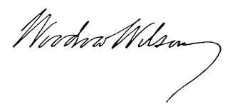
Annonymous Lady

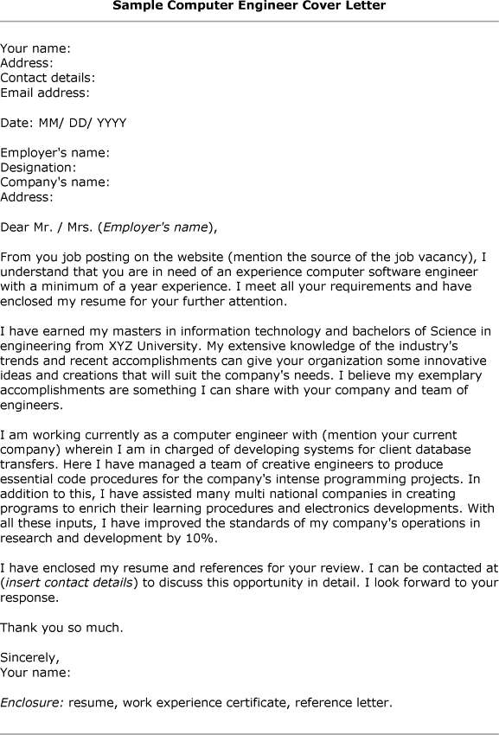

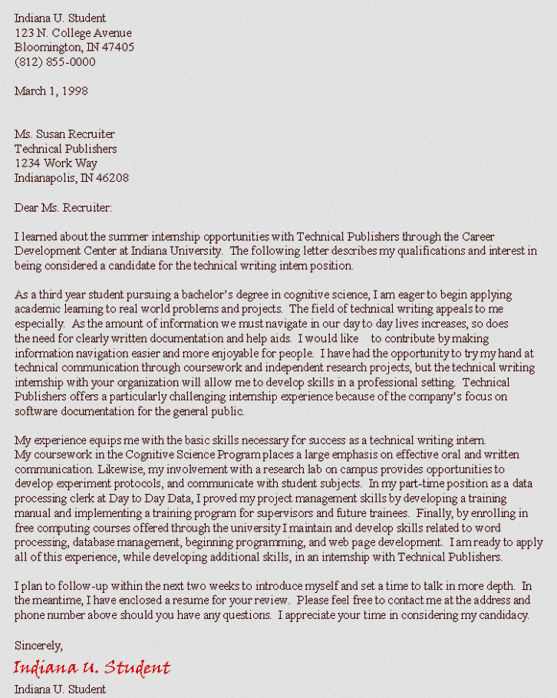
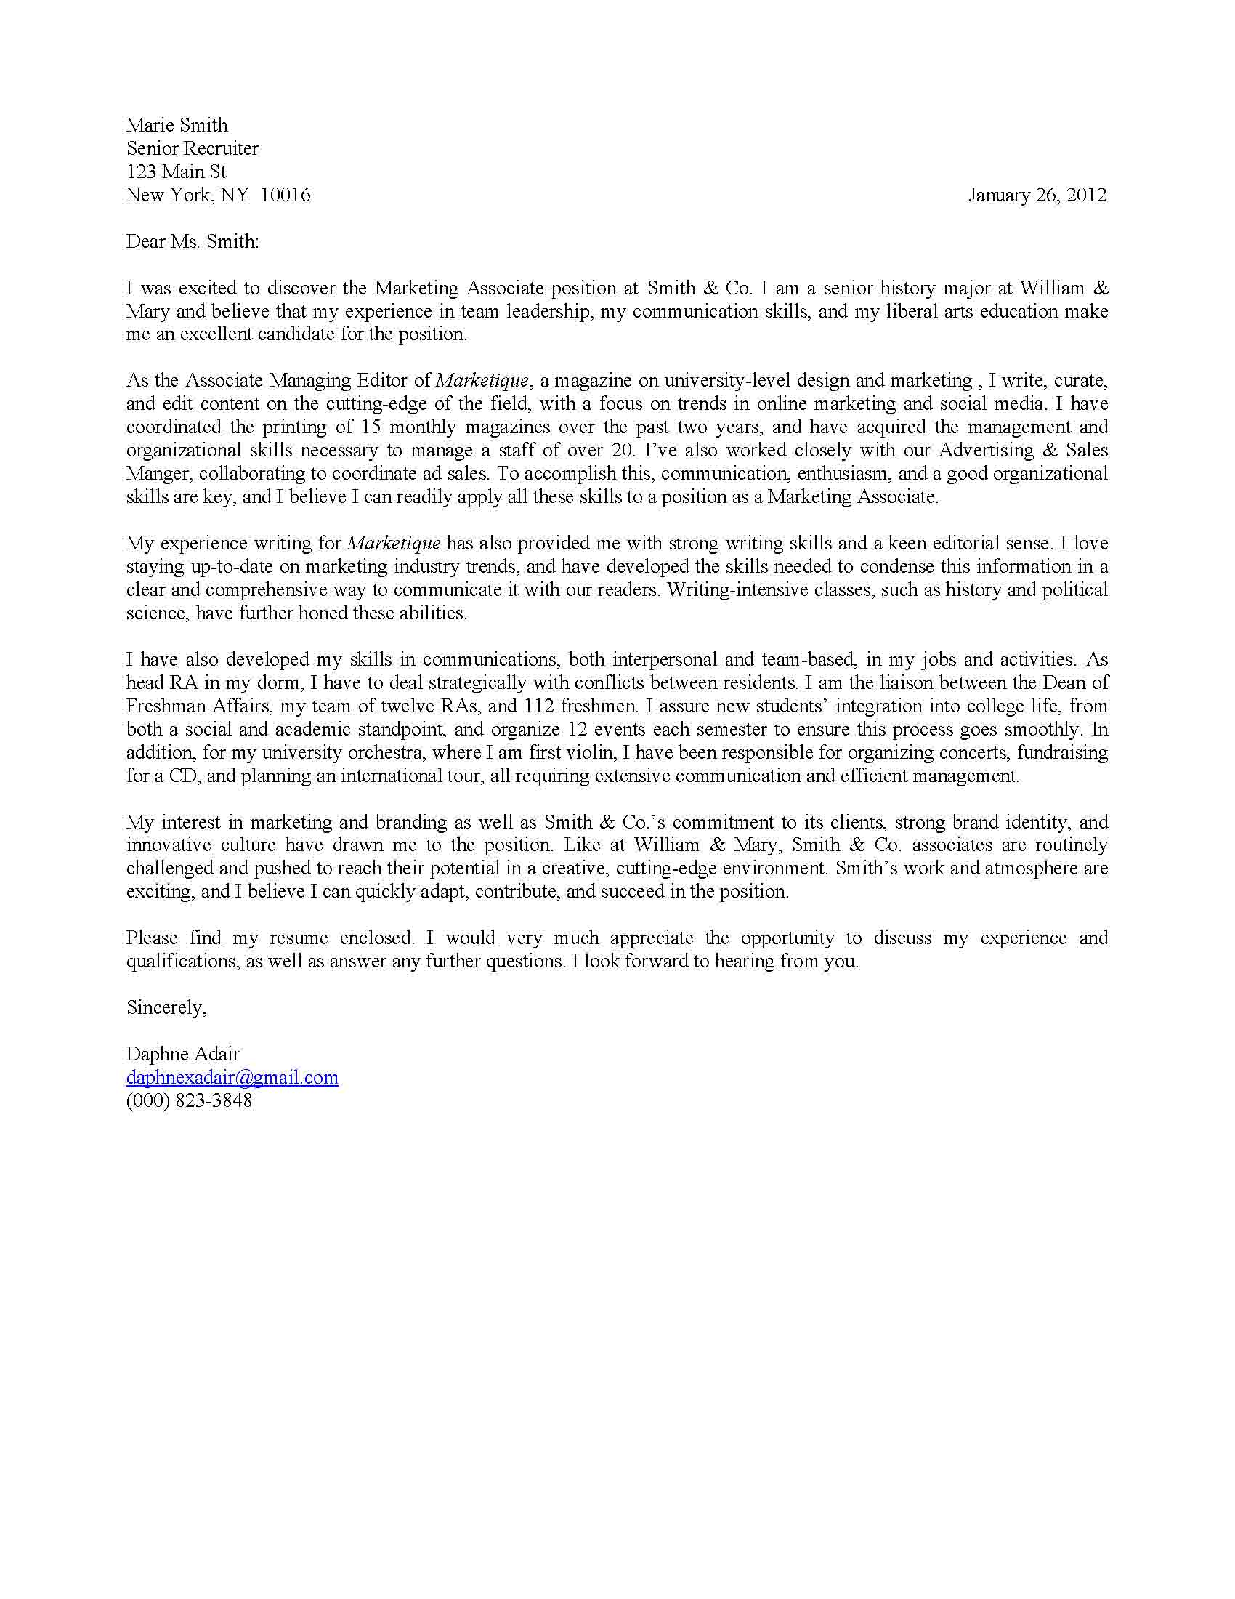
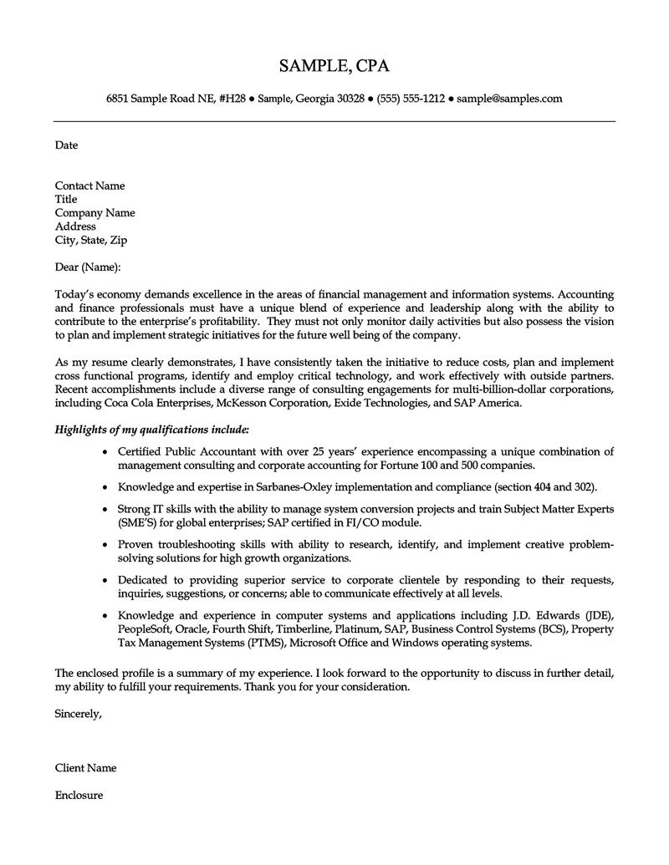
July 20, 2012
Ms. Sarah Gardenghi, M.A.
Director
English Language Institute
University of Maryland, Baltimore County
1000 Hilltop Circle
Baltimore, MD 21250

Dear Ms. Gardenghi,
I am writing to express my interest in applying for the Graduate Assistant Position within the International Student Services of the English Language Institute.
My name is Erin L. Berry and I am a newly admitted doctoral student within the department of Language, Literacy & Culture at the University of Maryland, Baltimore County and I look forward to continuing my research within the areas of Social Media, Interpersonal Communication, Cultural Studies, Feminism, Black Feminist Perspectives, Popular Culture, Race and Ethnicity, Ethnography, and Qualitative Research Methods in August of 2012.
I am a graduate of Bowie State University, where I received my Master of Arts degree in Organizational Communications and I am also a graduate of the University of North Carolina at Pembroke where I received a Bachelor of Science degree in Mass Communications. I have over eight years of experience in writing, reporting, interviewing, editing, organizing, researching, and planning. My strong work ethic, exceptional communication skills, and passion for research, writing and teaching have allowed me to participate in a myriad of diverse opportunities in and outside of the classroom.
Most recently, I have been working as a full-time faculty lecturer at Morgan State University within the department of Communication Studies. In this role, I taught undergraduate learners in the areas of Mixed Methods Research, Media Studies, and Public Speaking. Additionally, I also advised undergraduate students in class selections as they matriculated within the department and guided them in their graduate school pursuits and future career goals outside of academia.
My perseverance and passion for Community, Communication, Social Media, Higher Education, and Research have enabled me to pioneer through new territories of success. I am a self motivated; detail oriented, critical thinker, and team player who is capable of multi-tasking and meeting short deadlines in traditional as well as non-traditional environments. I am enthusiastic about new opportunities that will allow me to engage with new and returning students, faculty, and staff at the University of Maryland, Baltimore County.

I look forward to discussing my qualifications further through an interview so that I may provide you with portfolio samples to demonstrate abilities that I posses which are specific to your needs.

Sincerely,
Erin L. Berry
Erin L. Berry, M.A.
Enclosure: Curriculum Vitae

Use these verbs to add variety and specificity to
