The University of Maryland Baltimore and
University of Maryland Baltimore County

Doctoral Program in Gerontology Lecture Series
Presents

“Faces and Places: How Social Relationships and Residential Context Influence Health and Wellbeing in Assisted Living”

Debra Street, Ph.D.
Chair, Department of Sociology, University of Buffalo
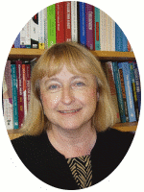
Debra Street, Professor of Sociology, chairs the UB Department of Sociology. She is the recipient of the 2011 SUNY Chancellor’s Award for Excellence in Teaching and the 2013-14 UB Gender Institute Janice L. Moritz Distinguished Lecture Award. She conducts research on issues associated with health and income security over the life course.

October 10, 2014
2:00 – 3:00 p.m.
Commons 331, UMBC
http://about.umbc.edu/files/2013/11/2013Map_General.pdf



