The Spring 2013 Social Sciences Forum lecture series is available online, and there are lectures that connect with your spring courses. Many professors bring their classes to the lectures, or offer extra credit to students for attending the talks and bringing the content back into their courses. Please consider including the following talks in your syllabi, and connecting the talks to your course. Many of the talks will be available online a few days after the event.

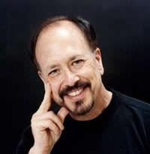 |  | Thursday, February 14 at 4pm  University Center, Room 310  More Sex is Safer Sex: The Unconventional Wisdom of Economics  Steven E. Landsburg, Professor of Economics at the University of Rochester  Steven Landsburg's writings are living proof that economics need not be "the dismal science." Readers of The Armchair Economist and his columns in Slate magazine know that he can make economics not only fun but fascinating, as he searches for the reasons behind the odd facts we face in our daily lives. In More Sex Is Safer Sex, he brings his witty and razor-sharp analysis to the many ways that our individually rational decisions can combine into some truly weird collective results -- and he proposes hilarious and serious ways to fix just about everything. From http://www.landsburg.com/  Co-sponsored by the Charles Koch Foundation

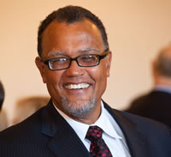 |  | Tuesday, April 2 at 4pm  Albin O. Kuhn Library, 7th Floor  Mr. Chips Goes to Detroit: Participating in the Auto Industry Rescue  Edward Montgomery, Dean, Georgetown Public Policy Institute at Georgetown University  Dr. Montgomery served as a member of President Obama's Auto Task Force and as Director of Recovery for Auto Communities and Workers. He will use his talk to discuss the economics and political considerations involved in the rescue of General Motors and Chrysler and efforts to rebuild the communities reliant upon the auto industry.  Co-sponsored by the Departments of Public Policy and Economics

More information about the lectures can be found at our website www.umbc.edu/socsforum

Feel free to contact me if you have any questions.
Sincerely,
Delana Gregg
UMBC Social Sciences Forum
410-455-2916
delana1@umbc.edu
www.umbc.edu/socsforum

