

**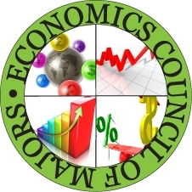**

**20% of sales benefit**

**Economics Council of Majors**

**Celebrity Scoopers include:**

**Treasurer**

**Wendy Baeg**

**umbceconCOM@gmail.com**

**Find us on facebook_logo at Rita’s in Arbutus**

**Join us for our**

**Celebrity Scoop**

**Night!**

**Tuesday April 26**

**5pm – 8pm**

**at Rita’s in Arbutus**

**5403 East Drive**

**Arbutus, MD**

**410-247-2422**

****