*Making your Money Work As Hard As You Do*

How to Make Smart Decisions about Your Money

In School and Beyond

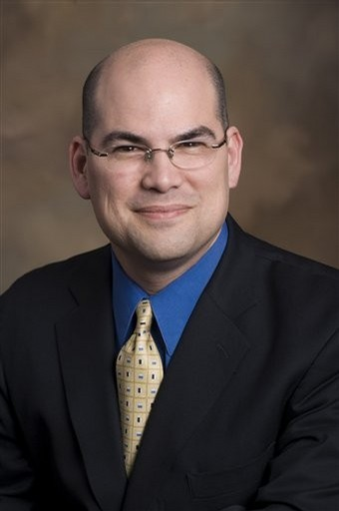

Stuart Ritter

Vice President at T. Rowe Price

Certified Financial Planner

Wednesday, December 8

12:00 – 1:00 P.M.

Lecture Hall 6