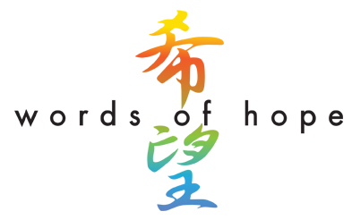
Desperately-needed food, water, clothing and other supplies are being rushed to the earthquake/tsunami/nuclear accident survivors in Japan. But as days turn into weeks turn into months, perhaps what the hundreds of thousands in shelters will need most is hope.

“Words of Hope for Japan” is the world’s effort to make sure the Japanese people know they are not forgotten. Schools, places of worship, scout troops, fraternities, sororities and other organizations as well as individuals can provide that hope simply by writing a letter sharing concern and encouragement. Children who can’t write can draw pictures. What is important is to do something to brighten the lives of the survivors and reassure them that they are not alone.

Our goal is to collect 300,000 letters - one for every man, woman and child in a Japanese shelter. Letters can be mailed to:

Words of Hope for Japan
P.O. Box 636
Fulton, MD 20759

All letters will be hand-delivered to the Embassy of Japan in Washington, D.C. for shipment to the shelters. Please do not enclose cash or checks.

Thank you in advance for your help!

For more information, contact Kathleen Koch.
kathleenlkoch@gmail.com

