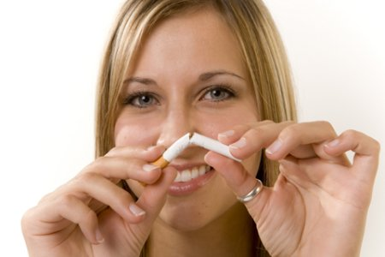

Freedom From Smoking

Freedom From Smoking is a course designed to help you quit for FREE.

When: Begins March 31st for 7 weeks
Day/Time: Thursdays, 4-5pm
Where: University of Maryland, Baltimore County (UMBC) – The Commons, Rm 332

Register now. Limited spaces available.

Contact Mickey Arora at parora@umbc.edu or 410-455-3752 for info.


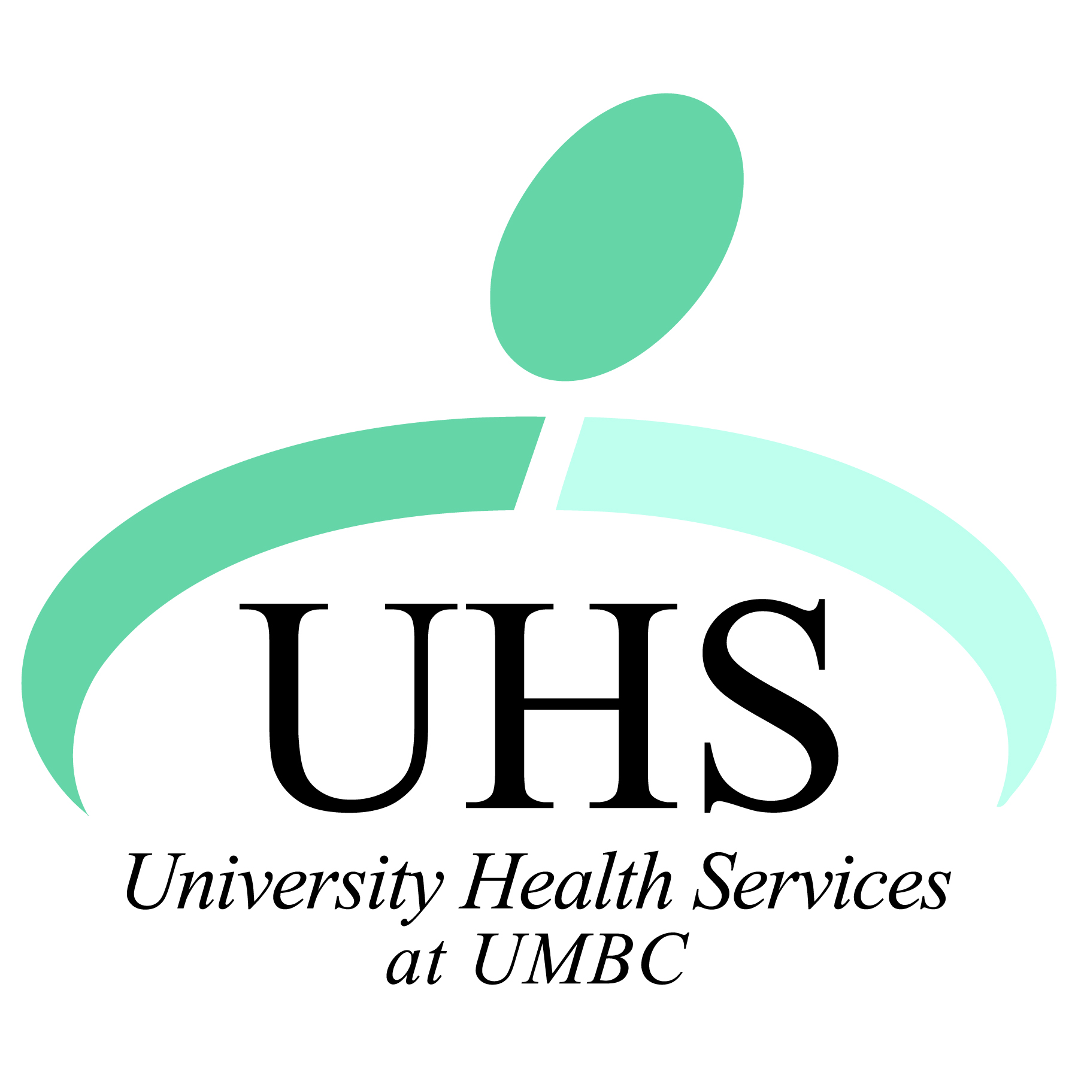
Sponsored by University Health Services and The Baltimore County Department of Health

