Black History Month Revisited through the most controversial film of the year…
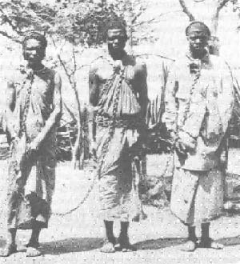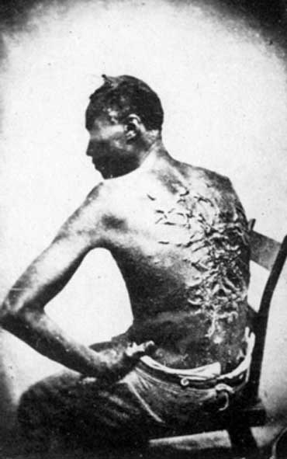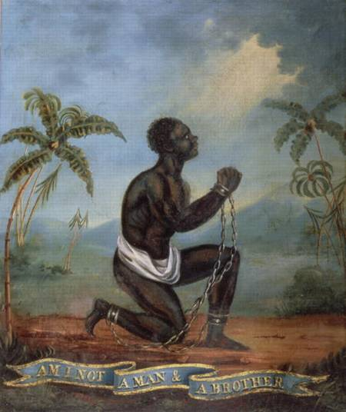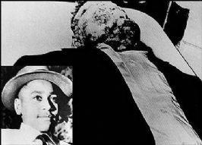

Racism has plagued us for centuries.
This documentary reveals what the government doesn’t want us to know; the gripping reality that racism still exists.
___________________________________________________

join the students of University of Maryland in the fight against racism and inequality.
Support the fight!
Even though the physical chains have been broken, we still have not been set free.
The Truth must be revealed. Don’t miss this once in lifetime free event!!

DATE: Friday, march 5th, 2010 @ 4:00pm.
Where: Hoff Theater, Stamp Student Union
Cost: FREE!!!!!

**Raffles, popcorn, prizes, and** **more!!!!!**

