How to access UMBCworks

UMBCworks is a great way to find out about internships that are posted through UMBC’s Shriver Center. Before you begin using this resource, please visit an advisor in the Shriver Center to get approved. Be sure to have your resume with you.

To begin, first you put your cursor on the **TOPICS** tab, after you’ve logged on to your myUMBC account. This will cause an option box to open underneath. Select **JOBS & INTERNSHIPS** .

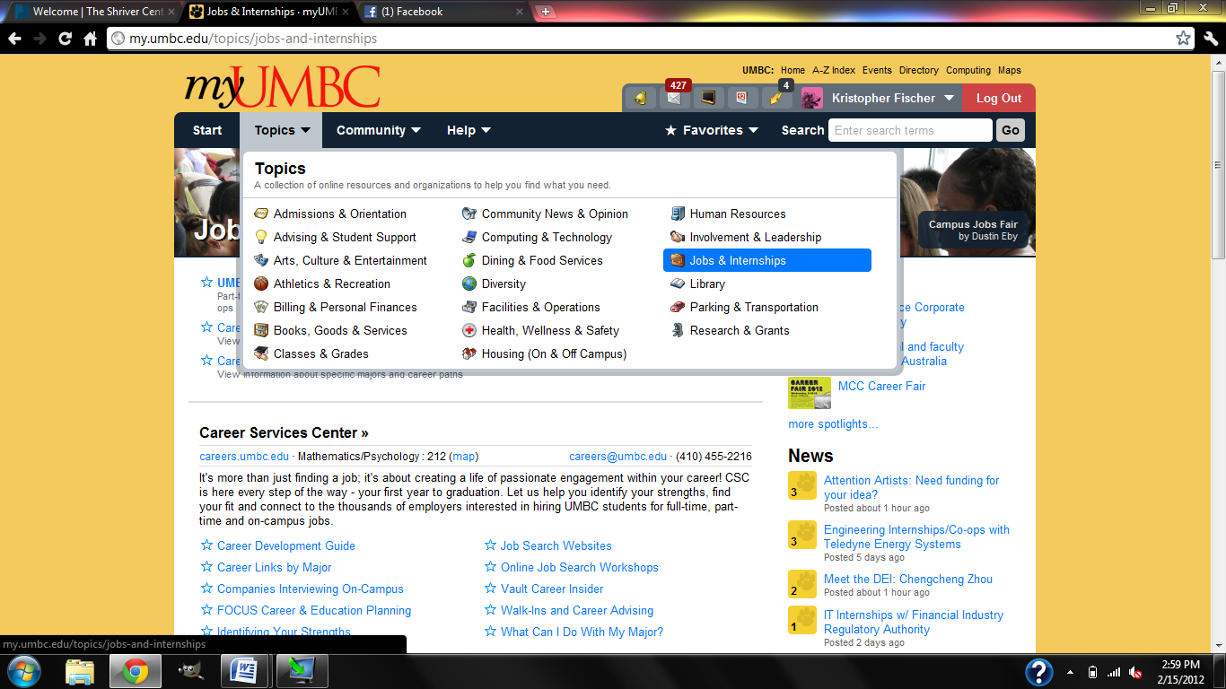

Then you will be directed to the page shown below. Select the UMBCWORKS link.

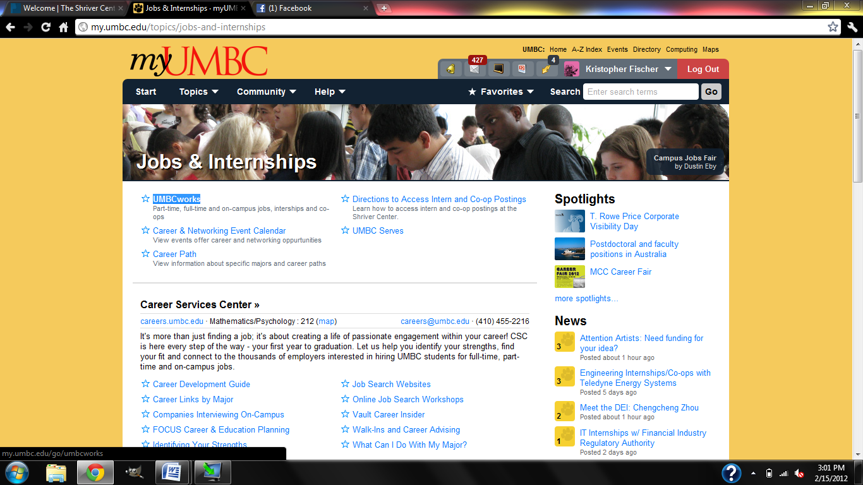

This will take you to UMBCworks, which you can use to upload your resume and apply to internships.

Visit an advisor in the Shriver Center before you start searching for internships. They can help you create and save your search information so you can have a far easier time in the future.